INTRODUCTION

The rapid development of digital technologies has significantly transformed the way educational and training processes are organised. In recent years, universities, private training centres, corporate academies and other educational organisations have increasingly begun to rely on digital platforms to support both administrative and learning-related processes. These platforms are used to manage enrolment, store information about learners, distribute learning materials, monitor attendance, track academic progress, collect homework submissions, process payments and evaluate learning outcomes. As a result, the educational environment is gradually moving from traditional paper-based and manually coordinated processes toward integrated digital ecosystems.
However, despite the wide availability of digital tools, many organisations still manage training activities through fragmented and weakly connected instruments. In practice, administrators may use spreadsheets to maintain learner lists, messengers to communicate with students, cloud folders to store learning materials, separate payment systems to track financial operations and manual documents to monitor attendance or performance. Such fragmentation leads to a number of organisational problems. Data is often duplicated across different sources, information becomes outdated or inconsistent, and employees spend additional time searching for the necessary details. In addition, the lack of a unified system reduces transparency of the training process and makes it more difficult for administrators, trainers and learners to coordinate their actions effectively.
In this context, Customer Relationship Management systems represent a relevant technological and methodological approach. CRM systems are traditionally used in business to manage interactions with customers, organise sales processes, track communication history and support data-driven decision making. Nevertheless, the same logic can be adapted to the educational and training domain. In this case, a learner may be considered as a “customer of educational services”, while the training organisation manages the learner’s full lifecycle: from the first request or registration to enrolment, participation in courses, progress monitoring, completion of the programme and further communication. This approach allows educational organisations to build a more systematic and learner-centred model of management.
The use of CRM principles in training management makes it possible to combine administrative, educational and communication processes within a single information environment. A CRM platform for training can store unified learner profiles, keep records of course participation, track attendance and homework submissions, support communication between users and provide administrators with structured information for decision making. Such a system can be especially useful for organisations where the number of learners, courses and trainers is constantly growing, and where manual coordination becomes inefficient and error-prone.
At the same time, existing Learning Management Systems and training platforms do not always fully solve these problems. Many LMS solutions are primarily focused on content delivery, online lessons, testing and assessment. Although these functions are important, they do not always cover the broader management needs of educational organisations. For example, some platforms provide limited tools for managing the full learner lifecycle, analysing interactions, supporting administrative workflows, tracking payments or maintaining communication history. As a result, organisations may still need additional tools outside the LMS, which again leads to fragmentation of information and processes.
In parallel with the development of digital learning platforms, artificial intelligence technologies are becoming increasingly important in the educational sphere. In particular, conversational AI assistants create new opportunities for supporting different participants of the training process. Such assistants can answer frequently asked questions, explain course information, help learners navigate the platform, provide recommendations, remind users about important tasks and support trainers or administrators in routine activities. The integration of an AI assistant into a CRM platform can therefore increase the practical value of the system by adding an intelligent communication layer to the traditional management functionality.
The use of an integrated AI assistant is especially relevant because educational and training organisations often deal with repetitive questions and routine communication. Learners may ask about lesson schedules, homework deadlines, course materials, attendance records, payment status or available programmes. Trainers may need support in organising course-related information, while administrators often have to process large amounts of operational data. If part of these tasks is supported by an AI assistant, staff workload can be reduced, communication can become faster, and learners can receive more personalised and timely support.
Thus, the development of a CRM platform for training with an integrated AI assistant is a relevant task. Such a system combines the advantages of CRM methodology, digital learning management and artificial intelligence technologies. It can help training organisations improve the quality of internal processes, reduce dependence on fragmented tools, increase transparency of learner data and provide more efficient communication between administrators, trainers and learners.
The object of this diploma project is the process of managing training activities in an educational or corporate environment using information technologies. This includes the organisation of courses, management of learners and trainers, monitoring of educational progress, coordination of administrative tasks and communication between participants of the training process.
The subject of the research is the development of a CRM platform for training with an integrated AI assistant that supports administrators, trainers and learners at different stages of the training lifecycle. The platform is intended to provide a unified digital environment for managing users, courses, lessons, homework submissions, attendance, payments, notifications and AI-supported communication.
The aim of this diploma project is to design and implement a prototype of a CRM platform for training with an integrated AI assistant in order to improve the organisation, transparency and efficiency of training management processes.
To achieve this aim, the following tasks are defined:
- To analyse theoretical approaches to CRM systems, digital learning platforms and the use of artificial intelligence in education.
- To study existing LMS, CRM and AI-based solutions and identify their limitations in the context of training management.
- To define the functional and non-functional requirements for the developed system.
- To design the architecture of the CRM platform, including its backend, frontend, database, storage and integration components.
- To develop the data model and describe the main entities of the system.
- To implement a prototype of the CRM platform with user management, course management, learning process tracking and supporting modules.
- To integrate an AI assistant component into the platform for supporting users during the training process.
- To test the developed prototype and analyse the obtained results.
The practical significance of the work lies in the creation of a prototype CRM platform that can be used as a basis for further development and deployment in an educational institution, private training centre or corporate academy. The proposed system can help reduce manual work, improve data consistency, support communication between participants and create conditions for more personalised training management. In addition, the project demonstrates how artificial intelligence can be integrated into a CRM-oriented educational platform not as a separate tool, but as a functional component of the overall training management process.
The diploma project consists of an introduction, three chapters, conclusion, list of references and appendices. The first chapter presents the theoretical background of CRM systems, digital learning platforms and the use of AI assistants in education. It also includes an analysis of existing solutions and identifies the main limitations that justify the need for the developed system. The second chapter describes the requirements, design decisions, architecture, data model and main components of the CRM platform with an integrated AI assistant. The third chapter is devoted to the implementation of the system prototype, including the backend, frontend, database, storage, AI integration, testing and analysis of the obtained results.
Overall, the project is aimed at demonstrating the practical possibility of combining CRM principles, learning management functionality and AI-based assistance within one integrated digital platform for training management.

1 ANALYSIS OF THE SUBJECT AREA, EXISTING SOLUTIONS AND SCIENTIFIC SOURCES

The development of digital technologies has significantly changed the way educational and training processes are organised. Modern universities, private training centres, corporate academies and professional development organisations increasingly rely on online platforms to manage learners, deliver learning materials, monitor progress and support communication between participants of the educational process. Digital tools have become an important part of both formal and non-formal education, as they allow organisations to store information, automate routine operations, provide remote access to materials and make the learning process more flexible.
At the same time, the digitalisation of education does not always lead to the creation of a unified and well-organised information environment. In many organisations, different functions are still distributed across several independent tools. For example, a learning management system may be used for lessons and assignments, spreadsheets may be used for learner lists and attendance tracking, messengers may be used for daily communication, e-mail services may be used for official notifications, and separate administrative systems may be used for payments or internal reporting. Although each of these tools can solve a specific task, together they often create a fragmented digital environment.
As a result, learner data, communication history, progress indicators and organisational records may remain separated from each other. This fragmentation makes it difficult to obtain a complete and reliable view of the learner and the training process. Administrators may need to manually compare information from different sources, instructors may not always have access to up-to-date data about learners, and learners may experience delays or inconsistencies in communication. In addition, duplicated data increases the risk of errors, while the absence of a unified system limits the ability of the organisation to analyse processes and make informed management decisions.
The subject area of this diploma project is located at the intersection of training management, customer relationship management and artificial intelligence. In the context of this work, training management is considered not only as the organisation of courses, lessons and educational materials, but also as a continuous process of managing relationships with learners. This means that the learner is viewed not only as a participant of a single course, but as a person who interacts with the organisation throughout a wider lifecycle: from the first contact and registration to course participation, progress monitoring, completion of the programme and possible further learning.
This approach is based on CRM principles, according to which an organisation should maintain a structured and long-term view of its interactions with customers, their needs, history and value for the organisation [1], [14]. In traditional business contexts, CRM systems are used to manage customer profiles, communication history, sales processes, segmentation and long-term engagement. When these principles are adapted to education and training, the learner becomes the central object of relationship management. The organisation should therefore be able to store and analyse information about the learner’s enrolments, progress, attendance, communication, payments, requests and overall interaction history.
The application of CRM logic to the educational domain makes it possible to build a more learner-centred model of training management. Instead of treating each course, lesson or message as an isolated event, the organisation can form an integrated picture of the learner’s experience. This is especially important for training centres and corporate academies where learners may participate in several programmes over time, communicate with different instructors and administrators, and require continuous support. A CRM-oriented approach helps to coordinate these interactions and makes the management process more systematic.
Learning Management Systems are widely used in education and training to support course delivery, learning materials, assignments and assessment [5]. These systems usually provide tools for creating courses, uploading materials, assigning tasks, checking submissions and evaluating learning outcomes. LMS platforms are therefore essential for organising the educational process at the course level. However, their functionality is often focused mainly on content delivery and academic assessment, while broader administrative and relationship-management processes may remain outside the system.
In particular, LMS platforms do not always provide a complete view of the learner across different programmes, communication channels and lifecycle stages. For example, an LMS may show the learner’s progress within a particular course, but it may not contain full information about previous courses, communication history, payment status, administrative requests or long-term engagement. This limitation becomes more visible when an organisation manages multiple courses, different groups of learners and several instructors at the same time. In such cases, the absence of a unified learner profile can reduce the efficiency of administrative work and the quality of support.
At the same time, CRM and Student Relationship Management approaches emphasise the importance of integrated learner profiles, communication history, segmentation, retention and long-term engagement [3], [4]. These approaches focus on the learner as a long-term participant in the educational ecosystem. They help organisations understand learner needs, maintain communication, identify risks of disengagement and support the learner throughout the entire educational journey. This creates the need for a platform that combines the operational functionality of training management with the relationship-oriented logic of CRM.
Such a platform should not only provide standard tools for managing courses and lessons, but also connect these tools with learner profiles, communication records, attendance data, homework submissions, payments and notifications. In this way, the system can support both everyday operational tasks and more strategic management activities. For administrators, this means better visibility of processes and reduced manual work. For instructors, it means access to relevant information about learners and their progress. For learners, it means clearer communication, faster support and a more personalised educational experience.
Another important factor influencing the subject area is the rapid development of artificial intelligence, especially conversational AI assistants and chatbots. AI-based assistants are increasingly used in education to answer frequently asked questions, support learners, help with administrative procedures and provide personalised guidance [8], [9]. These tools can improve the accessibility of support by allowing users to receive answers without waiting for direct assistance from administrators or instructors. They can also reduce the amount of repetitive work performed by staff, especially when many learners ask similar questions about schedules, deadlines, course materials or platform functionality.
However, the practical value of an AI assistant depends heavily on the context available to it. If such assistants are used as isolated add-ons, their usefulness is limited because they do not have access to structured institutional data. In this case, the assistant can provide only general answers and cannot reliably support tasks related to a specific learner, course, lesson or administrative process. For example, a standalone chatbot may explain general rules, but it cannot provide meaningful support if it does not know the learner’s course enrolment, homework status, attendance records or recent interactions with the organisation.
Therefore, the integration of an AI assistant into a CRM platform can make support more contextual, transparent and useful for learners, instructors and administrators. When the assistant operates within an information system that contains structured data, it can provide more relevant responses, help users navigate platform functionality and support decision-making processes. At the same time, such integration should be designed carefully, taking into account data protection, access control, role-based permissions and the limitation of context transferred to the AI component.
Thus, the development of a CRM platform for training with an integrated AI assistant is relevant because it addresses several important problems at once. It responds to the fragmentation of digital tools in training organisations, extends traditional LMS functionality with CRM-oriented learner management, and uses artificial intelligence as a support mechanism inside the platform rather than as a separate external service. This combination creates a foundation for improving transparency, communication, personalisation and operational efficiency in training management.
Chapter 1 analyses the subject area of the project, defines the relevance and problem statement, formulates the aim and objectives, describes training management processes and prepares the theoretical basis for the further design and implementation of the CRM platform with an integrated AI assistant. The chapter also explains why the combination of CRM principles, LMS functionality and AI-supported communication is suitable for solving the identified problems in the educational and corporate training environment. In addition, special attention is given to the limitations of fragmented digital tools and the need for a unified information environment that supports all key participants of the training process. This provides a foundation for the design decisions presented in the following chapters and helps justify the practical value of the developed system.

1.1 Relevance of the project and problem statement

The relevance of the project is determined by the growing digitalisation of educational and corporate training processes and by the need to overcome the fragmentation of learner-related data. Modern training organisations operate in conditions where learning activities are increasingly digital, hybrid and data-driven. Learners expect convenient access to courses, materials, schedules, feedback and support. Instructors need tools for managing lessons, assignments, attendance and communication. Administrators require reliable mechanisms for enrolment, user management, reporting and process control.
Despite this, many organisations still use a combination of separate tools (Fig. 1.1). A typical training process may involve an LMS for educational content, spreadsheets for learner lists, messengers for communication, e-mail for official notifications, cloud storage for materials and separate databases for administrative records.

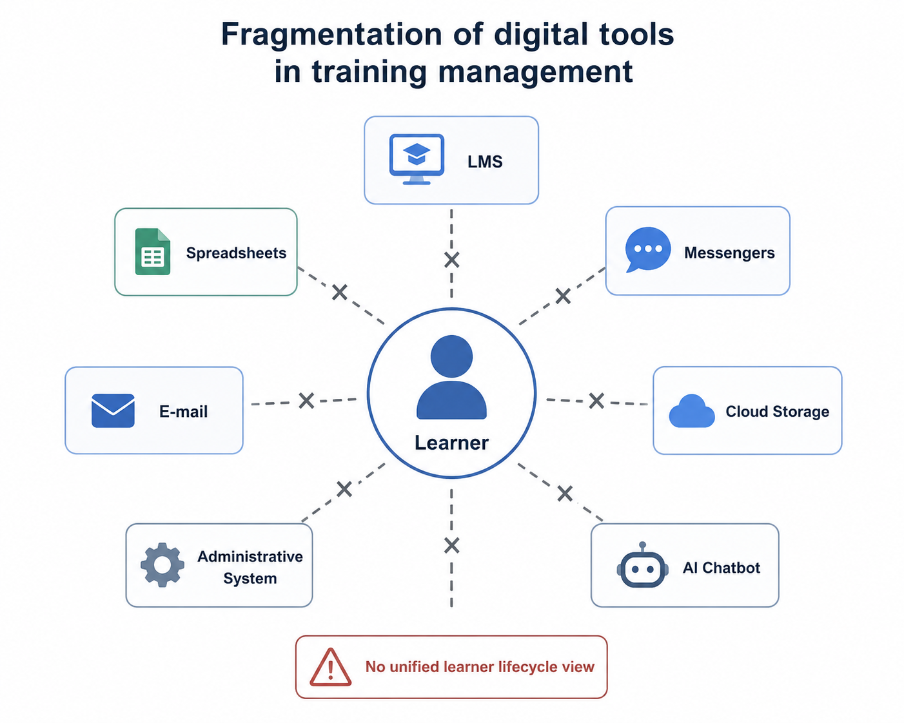

Figure 1.1 – Fragmentation of digital tools in training management

Each of these tools can be useful in isolation, but together they create several problems:
- duplication of learner data in different systems;
- inconsistent communication history;
- difficulty tracking the full learner lifecycle;
- manual preparation of reports and statistics;
- limited visibility of learner progress and engagement;
- weak integration of AI tools with real organisational data.
From the CRM perspective, this situation is problematic because relationship management requires an integrated view of the learner. CRM theory emphasises that effective relationship management depends on the ability to collect, organise and use information about interactions across different stages and channels [1], [14]. In education and training, this means that the organisation should be able to understand not only which course the learner attends, but also their enrolment history, progress, attendance, submissions, communication and support requests.
Existing LMS platforms partly solve the problem of course delivery, but they are usually not designed as full CRM systems. They manage content and assessment effectively, but often provide limited tools for relationship management, lifecycle tracking and cross-programme analytics [5], [6]. CRM systems, on the other hand, are usually designed for sales, marketing and customer support, and require adaptation to the specific logic of educational and training processes [3], [4]. AI assistants can improve communication and support, but without access to structured platform data they often remain limited to general answers rather than context-aware assistance [8], [10].
The main problem addressed in this diploma project can therefore be formulated as follows: existing digital tools for training management are not sufficiently integrated to provide a unified, CRM-oriented view of learners, training processes, interactions and AI-assisted support across the learner lifecycle.
This problem leads to practical consequences. Administrators spend additional time on manual data processing. Instructors do not always have a complete picture of learner progress. Learners may receive information from different channels without a single point of access. Managers have difficulty obtaining accurate statistics. AI assistants, when used separately, cannot fully support users because they are disconnected from institutional data.
To address these issues, the project proposes the development of a CRM platform for training with an integrated AI assistant. The platform is intended to centralise key information about users, courses, enrolments, lessons, materials, homework, attendance, payments, notifications and AI interactions. It should support the main user roles and provide a more structured, transparent and data-driven approach to training management.

1.2 Aim, objectives, object and subject of the diploma project
The aim of the diploma project is to design, implement and evaluate a CRM platform for training with an integrated AI assistant that supports lifecycle-based and data-driven management of learner relationships.
The object of the research is the process of training management and learner relationship management in educational and training organisations.
The subject of the research is the methods, models, software architecture and implementation approaches used to develop a CRM platform for training with an integrated AI assistant.
To achieve the aim of the project, the following objectives are defined:
- to analyse the subject area of training management and identify the main problems of fragmented digital tools;
- to study existing LMS, CRM, SRM and AI-based solutions used in education and training;
- to examine scientific sources related to CRM, learner lifecycle, LMS platforms and AI assistants;
- to define functional and non-functional requirements for the CRM platform;
- to design the system architecture, database model, user roles and core business processes;
- to compare and justify the selected technology stack;
- to implement the backend, frontend, database layer and file storage functionality;
- to integrate an AI assistant with controlled context passing and conversation handling;
- to test the main business scenarios of the system;
- to prepare deployment recommendations and identify directions for further development.
The practical result of the project is a working prototype of a CRM platform for training. The system is designed to support several user roles, including administrator, instructor and student. It provides functionality for managing courses, lessons, enrolments, materials, homework, attendance, payments, notifications and AI-assisted interaction.
Table 1.1 summarises the object, subject, aim and main expected result of the diploma project.

Table 1.1 – Object, subject, aim and expected result of the diploma project
Element | Description
Object | Training management processes and learner relationships in educational and training organisations
Subject | Methods, models, architecture and software implementation of a CRM platform with an integrated AI assistant
Aim | To develop and evaluate a CRM platform for training that supports lifecycle-based, data-driven learner relationship management
Expected result | A working web-based prototype with role-based access, course management, learner tracking, AI assistant integration, testing and deployment preparation

The project has both theoretical and practical significance. The theoretical significance lies in adapting CRM and learner lifecycle concepts to the training domain. The practical significance lies in creating a prototype that can be used as a basis for further development of a real platform for training centres, corporate academies or educational institutions.

1.3 Subject area analysis and training management processes

Training management is a complex and multi-stage process that includes planning, enrolment, course delivery, communication, assessment, learner support, reporting and further development of learners. In modern educational and corporate environments, this process involves multiple stakeholders and a large amount of information that must be collected, updated, interpreted and used for decision making. The quality of training management depends not only on the content of the course, but also on how effectively the organisation coordinates people, data, schedules, materials and communication channels.
In traditional training environments, many of these activities are performed manually or through separate tools. For example, course schedules may be stored in spreadsheets, communication may take place in messengers, homework may be submitted through e-mail, while payment and attendance records may be maintained in separate administrative files. Such an approach may be sufficient for a small number of learners, but it becomes inefficient when the organisation grows, launches several programmes at the same time or works with different groups of learners and instructors. Therefore, the subject area of training management requires an integrated digital solution that can support both educational and administrative processes.
The main stakeholders in training management are learners, instructors, administrators, programme managers and system support specialists. Each stakeholder group has its own tasks, responsibilities and information needs. Learners need convenient access to schedules, learning materials, homework, grades, notifications and support. Instructors need tools for managing lessons, uploading materials, tracking attendance, reviewing submissions and providing feedback. Administrators are responsible for user accounts, enrolment, payments, notifications, document flow and reporting. Programme managers need analytical information about participation, progress, learner engagement and overall programme effectiveness. System support specialists, in turn, are responsible for the stable operation of the platform, user access and technical support.
The interaction between these stakeholders is continuous and requires reliable information exchange. For example, when a learner enrols in a course, the administrator must register the enrolment, the instructor must see the learner in the group, the learner must receive access to materials, and the system must send the necessary notifications. If one part of this process is not synchronised with the others, errors may occur. A learner may not receive access on time, an instructor may not see an updated group list, or an administrator may lose track of payment or attendance information. This shows that training management is not a set of isolated actions, but a connected process that requires a unified information environment.
From the lifecycle perspective, the learner’s interaction with an organisation does not begin and end with a single lesson. It includes several stages:
- initial interest in a course or programme;
- registration and enrolment;
- participation in lessons and activities;
- access to materials and homework submission;
- assessment and feedback;
- completion of the programme;
- possible continuation of learning or re-enrolment.
This view is close to CRM logic, where the relationship with a customer is considered as a sequence of stages rather than as a single transaction [1], [14]. In the training domain, the same principle can be applied to learners. A learner may first contact the organisation to receive information about a programme, then register for a course, participate in training, submit homework, receive feedback, complete the programme and later return for another course. Each stage generates valuable information that can help the organisation understand the learner’s needs and improve the quality of service.
A training organisation should therefore be able to track the learner’s history, understand their current status, monitor progress and provide timely support. This is especially important when learners participate in several courses over time or interact with different instructors and administrators. Without a centralised learner profile, important information may be lost between departments or communication channels. A CRM-oriented approach helps to avoid this problem by creating a structured view of the learner and their interaction with the organisation.
Information flows in training management are also distributed across several categories. These include personal data, course data, enrolment data, attendance records, homework submissions, grades, learning materials, payment records, notifications and AI conversation history. Each category supports a specific part of the training process. Personal data is needed for identification and communication, course data describes the educational offer, enrolment data connects learners with programmes, attendance and homework records reflect participation, while payment and notification data support administrative operations.
If these data categories are stored in different systems, it becomes difficult to form a unified view of the learner. For example, an instructor may see homework submissions, but not payment status; an administrator may see enrolment data, but not learning progress; a programme manager may receive reports only after manual consolidation; and an AI assistant may answer general questions, but not know the learner’s actual course or schedule. As a result, the organisation cannot fully use its data to improve communication, support learners and make timely decisions.
Fragmented data also creates additional risks. Information may be duplicated, updated in one place but not in another, or interpreted differently by different employees. This may lead to mistakes in enrolment, delays in communication, inaccurate reports and lower quality of learner support. In addition, manual data transfer between tools increases the workload of staff and reduces the time available for more meaningful tasks, such as improving course quality or supporting learners individually.
For this reason, the proposed CRM platform is designed around the idea of centralised and structured data. The system should provide a single environment where the main training processes are connected and where each participant works with information relevant to their role. Centralisation does not mean that all users have access to all data. On the contrary, the platform should use role-based access control to ensure that learners, instructors, administrators and managers interact only with the information and functions that correspond to their responsibilities.
In the context of this project, the key training management processes are:
- user registration, authentication and role-based access;
- course creation and course administration;
- learner enrolment in courses;
- lesson planning and schedule management;
- material upload and access;
- homework creation, submission and grading;
- attendance tracking;
- payment record management;
- notification delivery;
- AI-assisted support;
- reporting and analytics.
These processes form the functional foundation of the future platform. User registration and authentication provide secure access to the system. Course administration allows the organisation to create and manage training programmes. Enrolment connects learners with courses and makes it possible to track participation. Lesson planning and material management support the educational process itself. Homework, attendance and grading help instructors monitor learner progress. Payment records and notifications support administrative coordination. Reporting and analytics provide managers with structured information for evaluating the effectiveness of training activities.
AI-assisted support is considered as an additional but important part of the platform. In the proposed system, the AI assistant is not treated as a separate chatbot outside the information environment. Instead, it is integrated into the CRM platform and can support users in the context of available platform data and role-based permissions. For learners, it may help with navigation, course-related questions and general support. For instructors, it may assist with routine explanations or organisation of information. For administrators, it may help reduce repetitive communication and support daily operational tasks.
These processes also show that the system is not limited to LMS functionality. It includes LMS-like elements, such as lessons, materials, assignments and assessment, but it extends them with CRM-oriented components: learner profiles, lifecycle tracking, interaction history, role-based communication, payment records, notifications and analytical support. This combination is important because training organisations need not only to deliver educational content, but also to manage relationships with learners throughout the entire training lifecycle.
The subject area analysis confirms that an integrated CRM platform can address several practical needs of training organisations. It can reduce fragmentation, improve process transparency, simplify access to learner information and create a foundation for AI-assisted support. Such a system can also improve coordination between stakeholders, reduce manual work and make training management more consistent and data-driven.
Therefore, the development of a CRM platform for training with an integrated AI assistant is justified by the complexity of modern training processes and the need for a unified digital environment. The proposed approach combines the operational functions of learning management with the relationship-oriented logic of CRM and the support capabilities of artificial intelligence. This provides the basis for the further analysis of existing LMS, CRM and AI-based solutions in the next section.

1.4 Analysis of existing LMS, CRM and AI-based solutions

The analysis of existing solutions is necessary in order to identify which functions are already covered by modern educational platforms and which limitations remain relevant for the development of an integrated CRM platform for training. In the context of this diploma project, three groups of solutions are considered: Learning Management Systems, Customer Relationship Management systems adapted to education, and AI-based assistants or chatbots used in educational and training environments.
Learning Management Systems are among the most widespread digital tools in education. They provide functionality for course creation, distribution of materials, assignments, quizzes, grading and communication between instructors and learners. Research on LMS platforms shows that these systems have become an important part of higher education infrastructure and are widely used to support online, blended and traditional learning formats [5]. Their main advantage is that they organise the educational process around courses and learning activities.
However, LMS platforms are usually focused on the course level. They are effective for managing materials, lessons and assessments, but they do not always provide a complete relationship-oriented view of the learner. In many cases, information about communication, payments, long-term learner history, support requests and interaction with administrators remains outside the LMS. As a result, the organisation can manage a course, but it may still lack a unified view of the learner across different programmes and lifecycle stages.
Classical CRM systems solve a different type of problem. They are designed to manage customers, contacts, communication history, sales pipelines, segmentation, marketing campaigns and customer support. CRM theory emphasises the importance of maintaining a unified customer profile and using data to support long-term relationship management [14]. In the education sector, CRM systems are often used for admissions, recruitment, marketing and communication with prospective students [4]. This demonstrates that CRM principles can be useful for educational organisations.
At the same time, standard CRM systems are not fully adapted to the specific needs of training management. They usually do not include native functionality for lessons, homework, attendance, grading, educational materials and learning progress. Therefore, when CRM systems are used in education, they often need to be integrated with LMS platforms or extended with additional modules. This creates another integration challenge: learner data may be divided between CRM and LMS, while neither system alone provides a complete view.
Student Relationship Management and Learner Relationship Management approaches try to overcome this gap by adapting CRM concepts to the educational domain. These approaches focus on the learner lifecycle, including the stages before, during and after participation in a programme. SRM and LRM systems aim to integrate data from different sources and support communication, retention, advising and analytics [15]. However, such solutions are not always available as complete ready-made systems, especially for smaller training organisations or custom training platforms.
AI-based assistants and chatbots represent another important category of solutions. They are increasingly used to answer common questions, guide students through administrative procedures, provide reminders, support learning activities and improve engagement [9]. The advantage of conversational agents is their accessibility and natural language interface. A learner can ask a question directly instead of searching through documents or waiting for an administrator’s response.
However, many AI assistants in education are implemented as separate tools or limited integrations. If the assistant does not have access to structured platform data, it can answer only general questions. It may not know the learner’s course, schedule, homework status or attendance history. This limits its practical value in real training management. Reviews of AI in education emphasise that intelligent systems are most useful when they are integrated with educational processes, institutional data and clear governance mechanisms [11].
The comparison of existing solution categories shows that each of them covers only part of the problem. LMS platforms support the educational process, CRM systems support relationship management, and AI assistants support communication and information access. The proposed platform combines these directions within one system: it includes LMS-like training management functions, CRM-oriented learner tracking and an integrated AI assistant.

Table 1.2 – Comparative analysis of existing solution categories
Solution category | Main strengths | Main limitations | Relevance to the proposed platform
LMS platforms | Course management, materials, assignments, grading, online learning support | Limited CRM functionality, weak lifecycle tracking, focus on separate courses | Provides educational process logic for lessons, materials and homework
Classical CRM systems | Unified customer profile, communication history, segmentation, relationship management | Not adapted to lessons, attendance, grading and learning processes | Provides relationship-oriented logic and learner profile concept
SRM / LRM solutions | Focus on learner lifecycle, retention, advising and educational relationship management | Often require integration with LMS and institutional systems | Provides conceptual basis for learner-centred CRM in training
AI assistants and chatbots | Natural language support, automation of routine answers, improved accessibility | Limited usefulness without structured platform context and control | Provides conversational interface for learners and instructors

The analysis confirms that there is a practical need for an integrated solution that combines these categories. Such a platform should not only deliver educational content, but also maintain learner profiles, track interactions, support analytics and provide AI-assisted communication based on structured data. This is the functional gap addressed by the developed CRM platform for training.

1.5 Scientific foundations of CRM, learner lifecycle and AI assistants

The scientific foundation of the project is based on three main conceptual areas: Customer Relationship Management, learner lifecycle and AI assistants in education. These areas define the logic of the system and explain why the proposed platform should combine training management, relationship management and conversational AI support (Fig .1.2).

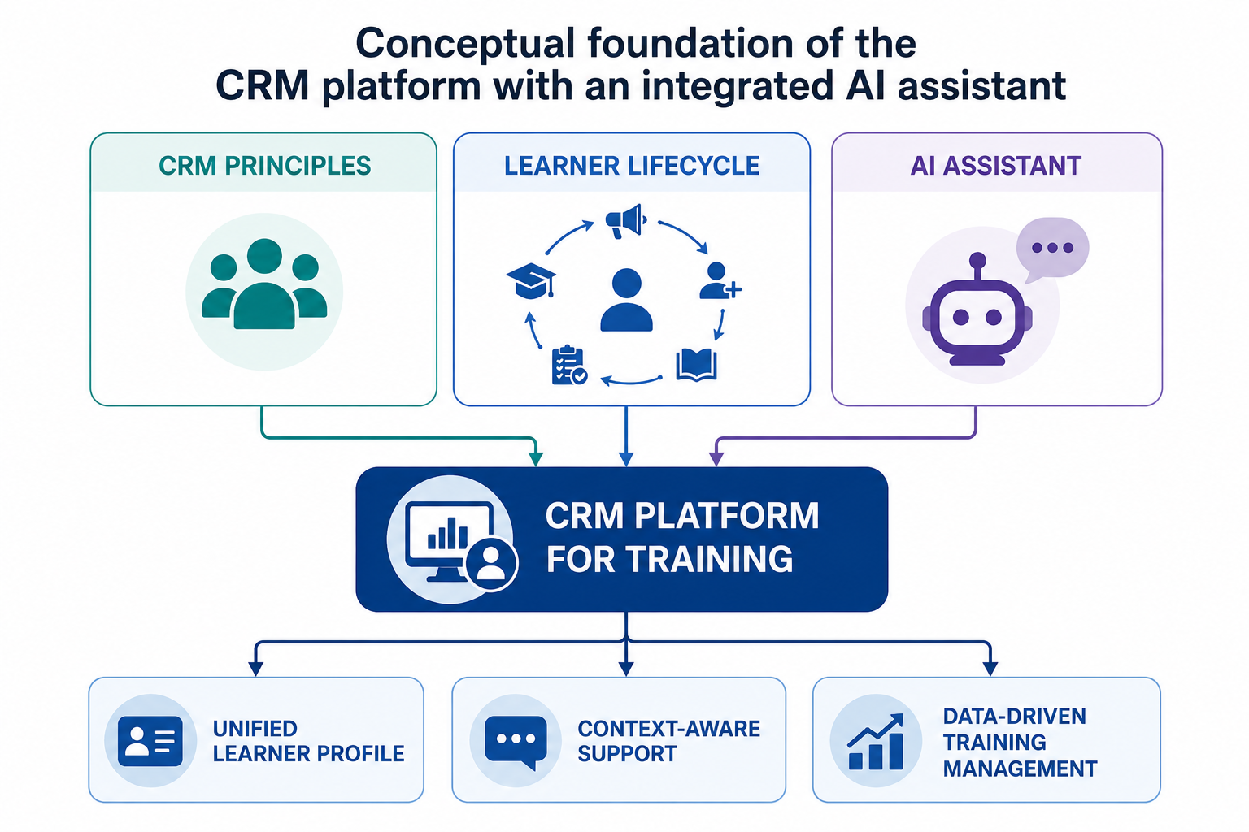

Figure 1.2 – Conceptual foundation of the CRM platform with an integrated AI assistant

Customer Relationship Management is usually understood as a strategic approach to managing long-term relationships with customers through the integration of processes, people and technologies. CRM is not limited only to software for storing customer contacts or managing sales activities. In a broader sense, it represents a management philosophy that helps organisations understand their customers, coordinate interactions with them and use data to increase the value of long-term relationships. Payne and Frow describe CRM as a framework that connects strategy, value creation, information management, multi-channel integration and performance assessment [1]. This definition is important because it shows that CRM combines both technological and organisational dimensions.
In modern CRM literature, the customer is viewed not only as a transaction participant, but as a long-term relationship object whose needs, interactions and behaviour should be systematically analysed [14]. This means that the organisation should not focus only on individual operations, such as a purchase, registration or request. Instead, it should maintain a structured view of the customer’s full journey, including previous interactions, current needs, communication preferences and future potential. Such an approach allows organisations to provide more personalised services, improve communication and make decisions based on accumulated data rather than isolated events.
The key idea of CRM is the creation of a unified customer profile. This profile may include personal data, contact information, communication history, service requests, preferences, transactions and other relevant records. The value of such a profile lies in the fact that different employees and departments can work with the same consistent information. As a result, the organisation can reduce duplication, avoid loss of important data and provide more coordinated support. This idea is directly relevant to educational and training organisations, where information about learners is often distributed across multiple systems and communication channels.
When CRM is adapted to education and training, the role of the customer is transformed into the role of the learner. This does not mean that education is reduced to a commercial service or that the learner is considered only as a source of revenue. Rather, it means that the organisation should treat the learner’s path as a continuous relationship that requires attention, communication, support and data-driven management. In this context, CRM principles help educational organisations focus not only on the delivery of lessons, but also on the quality of interaction with learners before, during and after the training process.
Studies on CRM in higher education show that CRM principles can help institutions improve communication, retention and the overall student–institution relationship [3]. For universities, training centres and corporate academies, this is especially important because the learner’s experience depends on many factors: the clarity of communication, access to materials, timely feedback, administrative support, transparency of progress and the possibility of continuing education. If these elements are managed separately, the organisation may lose a complete understanding of the learner’s needs and current status.
The learner lifecycle is one of the key concepts for adapting CRM to the training domain. In classical CRM, the customer lifecycle may include awareness, acquisition, development, retention and loyalty. These stages help an organisation understand how a customer enters the relationship, how their interaction develops, how value is created and how long-term engagement can be maintained. In the educational context, similar logic can be applied to learners, although the terminology and practical meaning of stages are different.
In the training domain, the learner lifecycle may include initial interest, registration, enrolment, participation in learning activities, assessment, completion and further development. At the initial interest stage, the learner searches for information about available courses or programmes. At the registration and enrolment stages, the learner becomes part of the organisation’s educational process. During participation, the learner attends lessons, receives materials, submits homework and communicates with instructors. At the assessment stage, the learner receives grades, feedback or other forms of evaluation. After completion, the learner may receive a certificate, continue learning or return to the organisation later for another course.
Each stage of this lifecycle generates data and interactions that should be recorded as part of the learner’s history. For example, registration creates profile data; enrolment creates a connection between the learner and a course; lessons create attendance records; homework creates submissions and grades; communication creates interaction history; payments create financial records; and AI conversations may create additional support history. If all these data elements are connected, the organisation can understand the learner’s journey more completely and provide more effective support.
For the proposed platform, the learner lifecycle is important because it changes the design focus of the system. The system should not be built only around courses or lessons. A course-centred design may be useful for organising content, but it does not always provide a full picture of the learner. Instead, the system should maintain a broader view of the learner across several processes and lifecycle stages. This approach makes it possible to understand not only what course the learner is taking, but also how they interact with the organisation as a whole.
In the context of the developed platform, the learner lifecycle includes the following processes:
- registration and profile creation;
- enrolment in courses;
- participation in lessons;
- access to materials;
- homework submission and grading;
- attendance tracking;
- payment and notification history;
- AI-assisted communication;
- completion and further learning opportunities.
These processes demonstrate that the learner’s experience is formed through a combination of educational, administrative and communication activities. Registration and profile creation provide the basic identity of the learner in the system. Enrolment connects the learner with specific courses. Participation in lessons, access to materials, homework submission and grading reflect the educational process itself. Attendance tracking, payments and notifications support administrative management. AI-assisted communication adds a new layer of support that can help users receive answers and guidance within the platform.
This lifecycle-oriented logic connects LMS and CRM approaches. LMS functionality is needed to manage lessons, materials, assignments and assessments. These functions are essential because they provide the operational basis for digital learning. Without LMS-like functions, the platform would not be able to support the everyday educational process. However, LMS functionality alone is not sufficient for full learner relationship management because it is often focused on course delivery rather than long-term interaction.
CRM functionality is needed to maintain a unified learner profile, communication history, lifecycle status and relationship context. It allows the organisation to see the learner not only as a participant of one course, but as a long-term participant in the educational environment. This is especially important for organisations where learners may take several courses, communicate with different instructors, return after completing a programme or require administrative support across different stages.
Student Relationship Management and Learner Relationship Management approaches provide a conceptual bridge between these two types of systems by focusing on learner relationships rather than isolated educational events [15], [16]. These approaches apply CRM thinking to education and emphasise the importance of communication, retention, engagement and learner support. In this sense, SRM and LRM show that educational organisations need systems that combine learning management with relationship management.
The third scientific foundation of the project is the use of AI assistants and conversational agents in education. Research in this area shows that AI tools can support learners and staff by answering questions, providing guidance, helping with navigation, generating explanations and automating routine communication [8], [9], [10]. Conversational agents are especially useful in situations where users repeatedly ask similar questions or need quick access to information. For example, learners may ask about lesson schedules, assignment deadlines, course rules, materials or platform functionality.
AI assistants can also support instructors and administrators. Instructors may use AI support to prepare explanations, answer routine learner questions or organise information. Administrators may benefit from AI tools that reduce repetitive communication and help users navigate organisational procedures. As a result, AI assistants can improve the speed and accessibility of support, especially when the number of learners and courses increases.
However, the value of such tools increases when they are connected to reliable data and embedded into real educational workflows. A standalone chatbot may provide general answers, but its usefulness is limited if it does not know the context of the learner, their course, current schedule, assignments or role in the system. Therefore, AI support should not be treated only as an external conversational interface. It should be connected with the platform’s structured data in a controlled and responsible way.
In the context of this diploma project, the AI assistant is not considered as a separate chatbot placed next to the platform. It is designed as an integrated subsystem that interacts with users through the platform interface and receives controlled contextual information from the system. This means that the assistant is part of the CRM platform and supports users within the same digital environment where courses, lessons, homework, attendance, notifications and learner profiles are managed.
This approach is important for several reasons. First, it allows the assistant to provide more relevant answers because it can use limited contextual information related to the current user request. For example, if a student asks about homework, the assistant may respond based on the course and assignment context available to that student. Second, it makes AI interactions part of the learner relationship history. This can help the organisation understand common questions, support needs and communication patterns. Third, it allows the system to apply role-based restrictions, logging and response control.
Role-based restrictions are particularly important for responsible AI integration. The assistant should not provide the same information to all users regardless of their role. A student should receive information related to their own courses and activities. An instructor may receive information about the courses they teach. An administrator may have access to broader operational information, but still within defined system permissions. This logic ensures that AI support follows the same access control principles as the rest of the platform.
At the same time, the use of AI requires careful design. AI systems can be useful, but they may also produce incomplete or inaccurate responses if the context is unclear or if the system lacks proper safeguards. In educational environments, this risk is important because learners may rely on the assistant for explanations, instructions or organisational information. Therefore, the platform should avoid giving the AI assistant uncontrolled access to data and should define clear boundaries for its use.
Studies on AI in education and AI in CRM emphasise the need for transparency, governance, data control and human oversight [10], [13], [18]. Transparency means that users should understand when they interact with an AI assistant and what type of support it provides. Data control means that the system should determine which information can be passed to the AI component and for what purpose. Human oversight means that AI should support users and staff, but should not replace important administrative or educational decisions where human responsibility is required.
Therefore, the platform must define what data can be passed to the assistant, which user roles can access AI functionality and how conversations should be stored and monitored. The context transferred to the AI assistant should be limited, structured and relevant to the current request. This reduces the risk of unnecessary data exposure and helps the assistant generate more accurate answers. Conversation storage should also be organised carefully, because AI interaction history may contain personal or educational information.
Thus, the scientific basis of the project can be summarised as follows:
- CRM provides the logic of structured relationship management and unified profiles;
- the learner lifecycle adapts CRM thinking to educational and training processes;
- LMS research explains the operational needs of digital learning platforms;
- SRM and LRM concepts connect relationship management with education;
- AI assistant research provides the basis for conversational support and automation;
- AI in CRM research highlights the importance of control, transparency and responsible integration.
Together, these concepts justify the development of a CRM platform for training with an integrated AI assistant. The platform is intended to combine structured data, lifecycle visibility and AI-supported interaction within one coherent system. Such a combination makes it possible to address both operational and communication-related problems of training organisations. It also provides a theoretical foundation for designing a system that supports not only course delivery, but also long-term learner relationship management.
As a result, the proposed platform can be understood as a synthesis of three main directions: CRM as a relationship management model, LMS as a digital learning management tool and AI assistant technology as a mechanism for intelligent support. This synthesis forms the conceptual foundation for the further design and implementation of the system described in the next chapters.

1.6 Requirements and methodological basis of the project

The requirements for the developed platform are derived from the subject area analysis, the comparison of existing solutions and the scientific foundations discussed above. The analysis has shown that modern training organisations require not only tools for delivering educational content, but also instruments for managing learners, communication, administrative records and long-term interaction history. Therefore, the developed system must respond to the key problems identified in training management: fragmented data, limited visibility of the learner lifecycle, manual reporting, uncoordinated communication and insufficiently contextual AI support.
In many educational and corporate training environments, information about learners is distributed across several independent systems. For example, learner profiles may be stored in one system, homework submissions in another, payment records in a separate file, and communication history in messengers or e-mail services. Such fragmentation makes it difficult to obtain a complete view of the learner and reduces the efficiency of decision making. For this reason, one of the main requirements for the platform is the creation of a unified digital environment where the main data categories and training processes are connected.
The requirements of the platform are divided into functional and non-functional requirements. Functional requirements define what the system must do and what operations it should support for different user groups. Non-functional requirements describe the quality characteristics of the system, including usability, security, reliability, maintainability and extensibility. This distinction is important because the success of the platform depends not only on the presence of specific functions, but also on how safely, conveniently and consistently these functions are implemented.
The functional requirements define the core behaviour of the CRM platform for training. The main functional requirements include user management, role-based access, course management, enrolment, lesson planning, material management, homework submission, attendance tracking, payment records, notifications, analytics and AI assistant integration. These functions reflect the practical needs of administrators, instructors and students. Together, they form the operational foundation of the platform and allow the system to support the complete training lifecycle from registration to course completion.
User management is one of the basic functional areas of the system. The platform must allow users to register, verify their e-mail address, log in securely and manage their profile information. Since different participants of the training process have different responsibilities, the system must support several user roles. The role model is necessary to separate access rights and prevent users from viewing or modifying information that does not correspond to their responsibilities. This is especially important because the platform stores personal data, educational records, payment information and AI interaction history.
The platform must support at least three main user roles: administrator, instructor and student. The administrator should be able to manage users, courses, enrolments, payments, notifications and system-level data. This role is responsible for maintaining the organisational structure of the platform and ensuring that the main administrative processes are performed correctly. Administrators should also have access to dashboards and reports that help evaluate the state of courses, learner participation and operational activity.
The instructor role is focused on the educational process itself. The instructor should be able to manage lessons, upload learning materials, create homework assignments, review submissions, assign grades, provide feedback and track attendance. The platform should provide instructors with a convenient view of their courses and learners so that they can quickly understand who is enrolled, who has submitted homework, who has missed lessons and which learners may require additional support. In this way, the system should help instructors reduce manual work and improve the quality of interaction with learners.
The student role is designed around access to learning activities and personal progress. The student should be able to view enrolled courses, schedules, lesson materials, homework assignments, grades, feedback, attendance records and notifications. The student should also be able to submit homework, receive updates and use AI support inside the platform. From the learner’s perspective, the system should be simple and predictable, because the main goal is not only to provide functions, but also to make the learning process more transparent and convenient.
The system must ensure that each user can access only the functionality and data appropriate to their role. For example, students should not be able to manage other users or change course settings; instructors should not have access to system-wide administrative functions unless explicitly granted; administrators should be able to manage operational data but should also work within defined access rules. This role-based access control is a key requirement for maintaining security, data integrity and correct separation of responsibilities.
Course management is another central requirement of the platform. The system should allow administrators or authorised users to create and edit courses, assign instructors, define course descriptions, dates, lesson structure and other relevant information. Courses should serve as the main organisational unit of the training process. Each course may contain lessons, materials, homework assignments, enrolled students and attendance records. This structure allows the platform to organise educational content and learner activity in a consistent way.
Enrolment management is required to connect students with courses. The system should support the registration of learners for specific programmes and maintain information about their participation. Enrolment data is important because it determines which learners have access to which courses, lessons and materials. It also supports reporting, progress tracking and communication. In a CRM-oriented platform, enrolment is not only a technical link between a user and a course, but also a part of the learner lifecycle that reflects the learner’s current relationship with the organisation.
Lesson planning and schedule management are necessary to organise the educational process in time. The platform should allow instructors or administrators to create lessons, define dates, attach materials and connect homework tasks to specific learning activities. Learners should be able to see upcoming lessons and understand what materials or assignments are related to each lesson. This improves transparency and reduces the need for repeated manual communication through messengers or e-mail.
Material management is required to provide access to learning resources in a structured way. The system should allow instructors to upload files or links, organise them by course or lesson and make them available to enrolled learners. This function is important because learning materials are often distributed through different channels, which may lead to confusion or loss of information. A centralised material repository makes it easier for learners to find the required resources and for instructors to keep course content updated.
Homework management is another important functional requirement. The platform should support the creation of homework tasks, submission of learner work, grading and feedback. Instructors should be able to monitor submission status and evaluate assignments, while students should be able to submit their work and view results. This function supports both learning control and communication between instructors and students. It also creates structured data that can later be used for analytics and progress monitoring.
Attendance tracking is required to record learner participation in lessons. Attendance data can be used by instructors to monitor engagement and by administrators to prepare reports. In corporate or professional training environments, attendance may also be connected with certification, payments or internal organisational requirements. Therefore, the platform should provide a convenient mechanism for recording and viewing attendance information.
Payment record management is included because many training organisations need to track financial interactions with learners. The system should allow authorised users to maintain payment-related information and connect it with learner profiles or enrolments. This does not necessarily mean that the prototype must implement a full payment gateway, but it should provide a structured way to record and view payment status. This is important for administrators who need to coordinate access, enrolment and financial records.
Notification management is required to support communication between the system and users. Notifications may inform learners about new lessons, homework deadlines, grades, feedback, payment updates or general announcements. They can also help instructors and administrators stay informed about important events. The presence of notifications reduces dependence on external messengers and makes communication more systematic.
Dashboard and reporting functionality is necessary for administrators, managers and instructors. The system should provide basic analytical information about courses, learners, attendance, homework submissions and other key indicators. Reporting is especially important because manual preparation of reports is one of the common problems in training organisations. Even basic dashboards can help users quickly understand the current state of the educational process and make decisions based on structured data.
The AI assistant must be integrated into the platform in a controlled and purposeful way. It should support learners and instructors by answering questions related to courses, schedules, assignments, platform functionality and general training processes. For learners, the assistant may help explain where to find materials, how to submit homework or what the next steps in the course are. For instructors, it may support routine communication and help organise information. For administrators, it may reduce the number of repeated questions and improve the speed of support.
At the same time, the AI assistant should not have unrestricted access to all system data. Context passed to the AI assistant must be limited, structured and relevant to the current user request. This is important for security, privacy and accuracy. The platform should provide only the information that is necessary for generating a useful response, while respecting the user’s role and permissions. For example, a student should not receive information about another learner’s grades or payment status through the AI assistant. Similarly, the AI component should not be treated as an uncontrolled external service with full access to the database.
Conversations with the AI assistant should be stored as part of the interaction history where appropriate. This can help users continue previous conversations, allow administrators to analyse common questions and improve the quality of support. However, storing AI conversations should also be implemented with attention to privacy, access control and data protection. The system should maintain a balance between usefulness and responsible data handling.
The main functional requirements can be summarised as follows:
- registration, login, e-mail verification and authentication;
- role-based access control for administrators, instructors and students;
- user profile management;
- course and lesson management;
- enrolment and learner tracking;
- material upload and access;
- homework creation, submission, grading and feedback;
- attendance management;
- payment and notification management;
- AI assistant integration;
- dashboard and reporting functionality.
Non-functional requirements describe the quality characteristics of the platform. These requirements are important because even a functionally complete system may be ineffective if it is difficult to use, insecure, unstable or hard to maintain. For the developed CRM platform, the most important non-functional requirements are usability, security, reliability, maintainability and extensibility.
Usability is important because the platform is intended for different user groups with different levels of technical experience. Administrators, instructors and students should be able to complete their main tasks without unnecessary complexity. The interface should be clear, consistent and role-oriented. For example, students should quickly find their courses and assignments, instructors should easily manage lessons and submissions, and administrators should have structured access to management functions and reports.
Security is critical because the platform stores personal data, educational records, payment-related information and interaction history. The system should use authentication, role-based access control and secure handling of user data. Passwords should not be stored in plain text, and access to sensitive information should be limited according to user roles. The AI assistant integration should also follow security principles by limiting the amount of data passed to the AI component.
Reliability is required to preserve important information and ensure stable operation of the main workflows. The platform should correctly store data about users, courses, enrolments, homework, attendance and payments. It should also handle common errors in a predictable way, such as invalid input, missing records or unauthorised access attempts. Reliable operation is especially important because training processes depend on timely access to schedules, materials and communication.
Maintainability is necessary because the platform may continue to develop after the prototype stage. The system should have a clear architecture, understandable code structure and separated components. This allows developers to modify existing functions, fix errors and add new features without rewriting the entire application. Maintainability is also supported by the use of versioned database migrations, structured APIs and modular frontend components.
Extensibility is important because the platform may later be expanded with new integrations, analytics or AI capabilities. For example, future versions may include integration with payment gateways, Telegram or e-mail services, advanced dashboards, recommendation systems or additional AI functions. Therefore, the architecture should not be limited only to the current prototype, but should provide a foundation for further development.
The methodological basis of the project combines analysis, modelling, prototyping, implementation and evaluation. This methodological structure allows the project to move from theoretical research to practical software development in a logical sequence. It also ensures that the implemented prototype is not created randomly, but is based on identified problems, analysed requirements and justified design decisions.
At the first stage, the subject area and scientific sources are analysed. This includes the study of CRM theory, LMS platforms, Student Relationship Management and Learner Relationship Management approaches, as well as AI assistants in education. The purpose of this stage is to understand the theoretical background of the project and identify the main limitations of existing approaches. The results of this stage form the basis for defining the problem statement and the relevance of the project.
At the second stage, requirements are formulated and the target system processes are defined. This includes identifying the main users of the platform, describing their tasks, defining functional and non-functional requirements and determining the key business scenarios. This stage connects the theoretical part of the work with the practical design of the future system.
At the third stage, the architecture, database model, diagrams and technology stack are designed. The architecture describes how the main system components interact with each other. The database model defines the main entities and relationships used to store platform data. Diagrams are used to visualise system processes, user interactions and technical structure. The technology stack is selected according to the requirements of the project, including backend, frontend, database, storage and integration components.
At the fourth stage, the prototype is implemented using a web-based client-server architecture. The backend provides business logic, API endpoints, authentication, access control, database interaction and integration with external services. The frontend provides user interfaces for administrators, instructors and students. The database stores structured information about users, courses, lessons, homework, attendance, payments and AI conversations. The AI integration provides conversational support within the platform.
At the final stage, the system is tested and evaluated according to key business scenarios. Testing is necessary to verify that the main functions work correctly and that users can complete the required actions. The evaluation focuses on whether the implemented prototype addresses the problems identified during the subject area analysis. This includes checking registration, authentication, role-based access, course management, learner interaction, homework submission, attendance tracking, notifications and AI assistant functionality.
The methodological process of the project includes the following steps:
- analysis of the subject area and existing solutions;
- formulation of the problem, aim and objectives;
- definition of functional and non-functional requirements;
- design of system architecture and database structure;
- selection and comparison of technologies;
- implementation of backend, frontend, database and AI integration;
- testing of key scenarios and validation of results;
- analysis of limitations and preparation of deployment recommendations.
The project follows an iterative and incremental development approach. This means that the system is not designed as a purely theoretical model, but is gradually developed through requirements analysis, architectural design, implementation and testing. Each stage clarifies or improves the results of the previous stage. For example, requirements influence the architecture, architecture influences database design, and implementation may reveal details that require refinement of individual functions or interfaces.
This approach is suitable for a diploma project because it makes it possible to connect theoretical analysis with practical software development. It also allows the prototype to be developed step by step, starting with the most important functions and then extending the system with additional modules. As a result, the final product demonstrates not only an understanding of the subject area, but also the practical ability to implement an information system that responds to real organisational needs.

2 DESIGN AND ARCHITECTURE OF THE CRM PLATFORM

Having analysed the subject area, existing solutions and scientific foundations of the project, the next stage is the design of the CRM platform for training with an integrated AI assistant. The purpose of this chapter is to transform the identified problems, limitations and requirements into a coherent system model that can be implemented as a working software prototype. Design in this context includes not only the visual representation of the future system, but also the logical description of its structure, behaviour, data flows and interaction between users and system components.
The design stage is especially important because it connects the theoretical analysis of Chapter 1 with the practical implementation described in Chapter 3. If the first chapter explains why the system is needed, the second chapter explains how the system should be organised in order to solve the identified problems. Therefore, this chapter includes the definition of business processes, functional and non-functional requirements, user roles, system architecture, database structure, diagrams and technology stack.
The developed platform is intended to solve the main problem identified in Chapter 1: the fragmentation of learner data, training processes, communication channels and AI support. In many training organisations, information about learners, courses, lessons, homework, attendance, payments and communication is stored in different systems or even in manual documents. This makes the management process less transparent and increases the workload of administrators and instructors. The proposed platform addresses this problem by creating a unified information environment where the main training processes are connected with learner relationship management.
Therefore, the platform is designed not as a separate LMS, chatbot or administrative tool, but as an integrated CRM-oriented environment for managing training activities and learner relationships. This means that the system combines several functional directions: educational process management, learner profile management, administrative support, communication and AI-assisted interaction. Such a design allows the platform to support both operational tasks, such as managing lessons or homework, and relationship-oriented tasks, such as tracking the learner lifecycle and maintaining interaction history.
The central idea of the design is that the learner should be treated as the main entity of the system. Courses, lessons, materials, homework submissions, attendance records, payments, notifications and AI conversations are connected to the learner and form a structured view of their educational journey. This approach makes it possible to analyse the learner not only within a single course, but across different stages of interaction with the organisation. As a result, administrators and instructors can work with more complete and consistent information.
The design of the platform is based on the following principles:
- integration of data and processes, so that learner profiles, courses, lessons, materials, homework, attendance, payments, notifications and AI conversations are connected within one system;
- role-based access, so that students, instructors and administrators work with different interfaces and different levels of data access;
- lifecycle orientation, so that the learner is managed not only within a single lesson or course, but across the broader learning process;
- modularity, so that each functional area of the platform is implemented as a separate module and can be maintained or extended independently;
- AI integration with controlled context, so that the assistant uses relevant platform data without receiving unrestricted access to sensitive information.
The principle of integration of data and processes means that the platform should reduce the need to use disconnected tools for everyday training management. Instead of storing learner lists in spreadsheets, materials in cloud folders, communication in messengers and reports in separate files, the main information should be connected through a single platform. This does not mean that all external tools are completely excluded, but the CRM platform becomes the central point where the most important data is structured and managed.
The principle of role-based access is necessary because different users interact with the platform in different ways. A student should be able to access enrolled courses, materials, homework, grades, notifications and AI support. An instructor should manage lessons, materials, submissions, attendance and feedback for their courses. An administrator should manage users, enrolments, courses, payments, notifications and reports. Role-based access also protects sensitive data and prevents users from performing actions that are outside their responsibilities.
The principle of lifecycle orientation reflects the CRM nature of the platform. A learner’s relationship with a training organisation begins before the first lesson and may continue after the completion of a programme. Therefore, the system should support not only separate educational events, but also a broader learner journey: registration, enrolment, participation, assessment, completion and possible further learning. This makes the platform different from systems that focus only on course content delivery.
The principle of modularity supports maintainability and future development. The platform is divided into functional modules, such as users, courses, lessons, materials, homework, attendance, payments, notifications and AI conversations. Each module has its own responsibility, but all modules are connected through common business processes and shared data structures. This makes the system easier to develop, test and extend. For example, in future versions it would be possible to improve the notification module, add advanced analytics or expand AI functionality without redesigning the entire platform.
The principle of AI integration with controlled context is one of the most important design decisions of the project. The AI assistant should not be implemented as an isolated chatbot that gives only general answers. At the same time, it should not have unrestricted access to the entire database. Instead, the platform should prepare a limited and structured context for the assistant based on the user’s role, current request and available permissions. This allows the AI assistant to provide useful support while preserving control over sensitive information.
The chapter follows the new structure of the diploma project. Section 2.1 presents the conceptual design and target business processes of the system. This section explains the general position of the platform in the digital environment of a training organisation and describes how the main business processes are connected. Section 2.2 defines the functional and non-functional requirements that determine what the system should do and what quality characteristics it should satisfy.
Section 2.3 describes the use case model and role-based access design. It explains how different user groups interact with the platform and which functions are available to each role. Section 2.4 presents the system architecture and main functional modules, including the frontend, backend, database, storage and external integrations. Section 2.5 covers database design and diagrams that visualise the structure and behaviour of the platform. Section 2.6 justifies the selected technology stack and compares it with alternative technologies.
The design decisions described in this chapter are connected with the theoretical foundations of CRM and learner relationship management discussed earlier. CRM literature emphasises the importance of a unified customer profile, structured interaction history and data-driven relationship management [1]. In the proposed platform, these principles are adapted to the training domain, where the learner becomes the central entity of the system. The learner profile serves as a point where educational, administrative and communication data are connected.
The platform also relies on the ideas of LMS, SRM and LRM approaches. LMS functionality provides the operational basis for managing courses, lessons, materials and assignments. SRM and LRM concepts extend this logic by focusing on learner relationships, long-term engagement and support across the educational lifecycle. The proposed system combines these perspectives by designing a platform that supports both learning management and relationship management.
In addition, the AI assistant component is designed in accordance with the need for contextual, controlled and transparent AI support. The assistant is not intended to replace instructors or administrators, but to support users by answering typical questions, helping with navigation and reducing repetitive communication. Its integration into the platform allows AI interactions to become part of the general learner support process rather than a separate external function.
Thus, Chapter 2 provides the design foundation for the implementation of the CRM platform with an integrated AI assistant. It defines how the system should be structured, how users interact with it, how data is organised and which technologies are selected for development. These design decisions create a logical bridge between the theoretical justification of the project and the practical implementation of the prototype.

2.1 Conceptual design and target business processes of the system

The conceptual design of the CRM platform defines the general position of the system within the digital ecosystem of an educational or training organisation. At this stage, the platform is considered not only as a software product, but also as an organisational solution that structures the main processes of training management. The conceptual design explains what role the system plays, which processes it connects and how it supports the interaction between learners, instructors and administrators.
In the current practice of training management, different processes are often distributed across several independent tools: LMS platforms, spreadsheets, messengers, e-mail services, cloud storage and administrative systems. Each of these tools may be useful for a specific task, but together they often create a fragmented information environment. For example, learning materials may be stored in cloud folders, attendance may be recorded in spreadsheets, homework may be submitted through messengers, while payment records may be managed separately by administrators. As a result, the organisation does not have a single reliable source of information about the learner and the training process.
This fragmentation leads to duplicated data, weak coordination and limited visibility of the learner lifecycle. Employees may need to manually transfer information between systems, check different sources before making decisions and repeat the same communication through several channels. Instructors may not always have access to up-to-date learner information, while administrators may not see the full educational progress of a student. Learners, in turn, may face uncertainty about schedules, assignments, materials or feedback. Therefore, the conceptual design of the platform is based on the need to reduce fragmentation and create a more integrated digital environment.
The proposed CRM platform is designed as a central coordination layer that connects the main training-related processes. It does not aim to replace all possible external systems, because in practice educational organisations may continue to use external communication tools, payment services or storage solutions. However, the platform provides a unified operational environment where the most important data and actions are structured around learners, courses and interactions. In this sense, the system acts as a central point for organising training activities and maintaining a consistent view of the learner.
This approach corresponds to CRM and SRM principles, where relationship management depends on the integration of data from different touchpoints [3], [4], [15]. In business CRM systems, customer information is collected from various channels in order to create a complete customer profile. In the educational context, the same logic can be applied to learners. The platform collects and connects information about registration, enrolment, course participation, attendance, homework, payments, notifications and AI conversations. This makes it possible to understand the learner’s current status and history more clearly.
At the conceptual level, the platform consists of three major dimensions.
First, the platform supports training process management. This dimension includes user registration, course creation, enrolment, lesson scheduling, material upload, homework submission, attendance tracking and grading. These functions are close to LMS functionality because they are directly related to the organisation of learning activities. However, in the proposed platform they are adapted to the broader CRM-oriented logic of the system. This means that lessons, materials and homework are not treated as isolated educational objects, but as parts of the learner’s overall lifecycle and interaction history.
Training process management provides the operational foundation of the platform. It allows administrators to create and organise courses, instructors to manage lessons and assignments, and learners to access the necessary educational resources. The system should support the main routine actions that occur during the training process: creating a course, enrolling learners, planning lessons, uploading materials, assigning homework, receiving submissions, recording attendance and evaluating results. These actions form the basic workflow of the educational process.
Second, the platform supports learner relationship management. This dimension includes unified learner profiles, enrolment history, progress indicators, notifications, payment records and interaction history. These elements allow administrators and instructors to see not only isolated educational events, but also the learner’s broader trajectory. For example, the platform can show which courses the learner is enrolled in, what lessons they attended, what homework they submitted, what notifications they received and what interactions were recorded.
Learner relationship management is the key difference between a standard LMS and the proposed CRM-oriented platform. In many LMS platforms, the main focus is placed on a specific course and its materials. In contrast, the CRM approach focuses on the learner as the central object of the system. This makes it possible to build a more complete view of the learner’s interaction with the organisation. Such a view is useful for improving communication, supporting retention, identifying learner needs and making administrative decisions.
Third, the platform includes AI-assisted support. The AI assistant is integrated into the platform as a controlled subsystem that can provide explanations, answer questions and help users navigate training-related information. Unlike a standalone chatbot, it is connected to selected platform data and works within role-based limitations. This means that the assistant does not operate separately from the system, but becomes part of the platform’s communication and support infrastructure.
The AI assistant can support different groups of users. For students, it can help answer questions about courses, schedules, homework, materials and platform functionality. For instructors, it can help with routine explanations and navigation through course-related information. For administrators, it can reduce repetitive communication and support operational tasks. At the same time, the AI assistant must be designed carefully. It should receive only limited and relevant context, and it should not bypass the access rights defined by the platform.
The target “to be” model of the platform includes several core business processes:
- user registration, authentication and e-mail verification;
- role-based access for students, instructors, administrators and super administrators;
- creation and management of training courses;
- enrolment of students in courses;
- planning and management of lessons;
- upload and access to learning materials;
- creation, submission and grading of homework;
- attendance tracking for lessons;
- management of payment records;
- delivery of system notifications and Telegram notifications;
- interaction with the AI assistant;
- dashboard and reporting functionality.
These processes are connected with each other and form a single training management lifecycle. For example, user registration creates the initial user profile; authentication and e-mail verification provide secure access to the system; role-based access determines which functions are available to the user. Course creation enables enrolment, while enrolment gives students access to lessons, materials, homework and notifications related to a specific course.
Lessons are connected with materials, homework and attendance. Materials provide learning content, homework supports assessment and feedback, and attendance records reflect participation in the educational process. Homework and attendance contribute to learner progress indicators, which can be used by instructors and administrators to evaluate engagement and identify possible issues. Payment records and notifications support the administrative side of training management, while reporting functionality helps managers analyse the state of the training process.
Notifications play an important role in connecting the system with users. They can inform learners about new lessons, homework deadlines, grades, feedback or administrative updates. Telegram notifications extend this communication beyond the platform interface and make messages more accessible to users in their everyday communication environment. This helps reduce the risk of missed information and supports more timely interaction between the organisation and learners.
The AI assistant can use selected context from these processes to provide more relevant responses. For example, if a learner asks about an assignment, the assistant may use information about the learner’s enrolled course and available homework tasks. If a user asks about the schedule, the assistant may refer to lesson information available for that user. However, this context must be limited by the user’s role and permissions. A student should not receive information about other students, and an instructor should only access information related to their own courses unless additional permissions are granted.
From the architectural point of view, the conceptual model assumes that the platform is organised as a web-based client-server system. The frontend provides interfaces for different user roles, the backend implements business logic and access control, the database stores structured information, and external integrations support AI communication, Telegram notifications, e-mail delivery and file storage. This division makes the system easier to maintain and extend.
The conceptual design also assumes that the platform should be modular. Each functional area, such as users, courses, lessons, homework, attendance, payments, notifications and AI conversations, should be represented as a separate logical module.
Such modularity allows the system to be developed incrementally. It also makes it possible to expand the platform in the future, for example by adding advanced analytics, integration with payment gateways, recommendation mechanisms or additional AI functions.
Thus, the conceptual design of the CRM platform reflects the main idea of the project: to combine training process management, learner relationship management and AI-assisted communication within one coherent system. The platform is intended to reduce fragmentation, improve transparency of learner data, support role-based interaction and provide a foundation for more personalised and efficient training management. This conceptual model becomes the basis for the further architectural design, database modelling and implementation decisions described in the following sections.

Table 2.1 – Target business processes of the CRM platform
Business process | Main users | Main outcome
User and access management | ADMIN, SUPER_ADMIN, STUDENT, INSTRUCTOR | Secure registration, authentication and role-based access
Course management | ADMIN, INSTRUCTOR | Structured catalogue of training courses
Enrolment management | ADMIN, STUDENT | Connection between learners and courses
Lesson and schedule management | INSTRUCTOR, STUDENT | Organised learning process with lesson statuses
Material and homework management | INSTRUCTOR, STUDENT | Access to learning resources and assessment activities
Attendance and progress tracking | INSTRUCTOR, STUDENT, ADMIN | Visibility of learner participation and performance
Payment management | ADMIN, STUDENT | Tracking of course-related financial records
Notification management | All roles | Timely communication through platform and external channels
AI-assisted support | STUDENT, INSTRUCTOR | Context-aware help and conversational interaction
Analytics and reporting | ADMIN, INSTRUCTOR | Aggregated data for monitoring and decision-making

As shown in Table 2.1, the platform combines educational, administrative, communicational and analytical processes within one system. This makes it different from a classical LMS, which is usually focused on lessons and materials, and from a classical CRM, which is usually focused on customers, contacts and sales processes. The proposed platform combines both approaches and adapts them to the training domain.
The conceptual design also assumes that each process should be reflected in the system architecture and data model. Therefore, the platform must include modules for users, courses, enrolments, lessons, materials, homework, attendance, payments, notifications, analytics and AI assistant functionality. These modules will be described in more detail in the following sections.

2.2 Functional and non-functional requirements of the platform

The requirements of the CRM platform are derived from the problem statement, subject area analysis and target business processes. They define what the system must do and what quality characteristics it must satisfy. In this project, requirements are divided into functional and non-functional requirements.
Functional requirements describe the actions and features that the platform must provide to its users. Since the system supports several roles, functional requirements are closely connected with role-based access. The platform must allow each user to perform only those operations that correspond to their role and responsibilities.
The main functional requirements of the platform include the following:
- the system must support user registration, authentication, e-mail verification and password management;
- the system must provide role-based access for STUDENT, INSTRUCTOR, ADMIN and SUPER_ADMIN;
- the system must allow administrators to create, edit, activate and deactivate user accounts;
- the system must allow administrators and instructors to create and manage courses;
- the system must allow students to be enrolled in courses;
- the system must support lesson creation, scheduling, status management and conflict prevention;
- the system must allow instructors to upload materials and attach them to lessons;
- the system must support homework creation, student submissions, grading and feedback;
- the system must allow instructors to mark attendance using predefined statuses;
- the system must support payment rules and payment records for courses;
- the system must provide notifications inside the platform and through Telegram integration;
- the system must provide dashboards and analytics for administrators and instructors;
- the system must integrate an AI assistant for students and instructors;
- the system must log AI conversations and control the context passed to the AI provider.
These requirements reflect the platform’s dual nature. On one side, it has LMS-like requirements related to courses, lessons, materials and homework. On the other side, it has CRM-like requirements related to learner profiles, interactions, notifications, analytics and AI-assisted support. This combination is necessary because the project aims to manage the learner lifecycle rather than only isolated learning events.
Non-functional requirements define how the system should operate. They are especially important because the platform works with personal data, educational records and AI-generated responses. The main non-functional requirements include usability, security, reliability, performance, maintainability, extensibility and integration readiness.
Usability means that the interface must be understandable for students, instructors and administrators. Each role should see relevant information and actions without unnecessary complexity. For example, a student should easily find enrolled courses, schedules, homework, grades and AI chat. An instructor should be able to manage lessons, materials, attendance and submissions. An administrator should have access to user management, enrolment, payments and dashboard functions.
Security is one of the most important requirements. The platform must protect personal data, authentication credentials, educational results and payment-related records. This is achieved through JWT-based authentication, role-based authorisation and controlled access to backend endpoints. Security is also important for the AI assistant because only limited and relevant context should be passed to the external AI provider.
Reliability means that the system should correctly preserve user actions and important records. For example, homework submissions, attendance marks, grades and payment records must not be lost because of interface errors or integration failures. The system should also handle exceptional situations, such as incorrect input, unavailable external services or invalid user actions.
Performance requirements for the prototype are defined according to the expected load of a small or medium training organisation. The platform should support typical operations such as login, dashboard loading, course navigation, lesson management and homework submission within acceptable response time. The architecture should also allow future scaling if the number of users and courses increases.
Maintainability and extensibility are important because the platform may later be expanded with additional modules, advanced analytics, LMS integrations, payment providers or improved AI functions. For this reason, the system is designed with a separation between frontend, backend, database, file storage and external integrations. This structure makes it easier to modify one part of the system without rewriting the entire platform.
The requirements can be summarised as follows:
- functional completeness: the platform must cover the key training and CRM processes;
- role clarity: each user role must have clearly defined permissions and interface functions;
- data consistency: learner, course and interaction data must be stored in a structured way;
- security and privacy: sensitive data must be protected and AI context must be controlled;
- technical maintainability: the system must have a modular architecture;
- integration readiness: the system must be prepared for external services such as AI providers, file storage, e-mail and Telegram;
- practical usability: the platform must be convenient for real educational and training scenarios.
These requirements provide the foundation for the use case model, architecture and database design described in the following sections. They also define the criteria by which the implemented prototype will later be tested and evaluated in Chapter 3.

2.3 Use case model and role-based access design

The use case model of the CRM platform defines how different categories of users interact with the system and which functions are available to each role. Since the platform is designed for training management, it must support several types of users whose responsibilities differ significantly. A student needs access to learning materials, homework, schedules and grades. An instructor needs tools for managing lessons, assignments, attendance and student progress. An administrator is responsible for user management, enrolment, payments and general operational control. A super administrator has the highest level of access and manages global platform configuration.
The role model of the system is therefore based on the principle that each user should see only the functions that are necessary for their work. This approach improves usability, because the interface is not overloaded with irrelevant actions, and also strengthens security, because users cannot access data or operations outside their authority. In the context of CRM-oriented training management, role separation is especially important, since the platform stores personal data, educational results, payment records and AI conversation history.
The main roles of the platform are STUDENT, INSTRUCTOR, ADMIN and SUPER_ADMIN. The student role represents learners who participate in courses and interact with the educational process through the platform. The instructor role represents teachers or trainers responsible for organising lessons, uploading materials, assigning homework and evaluating student work. The administrator role supports operational management, including users, courses, enrolments and payment records. The super administrator role extends the administrator role and provides access to system-wide settings and advanced management functions.
The use case model (Fig 2.1) is built around the idea that each role participates in the training lifecycle from a different perspective. For example, the student experiences the platform as a personal learning space, while the instructor experiences it as a teaching and monitoring tool. The administrator, in turn, uses the system as a management environment for coordinating users, courses and records. This separation allows the system to support the same training process from several connected viewpoints.

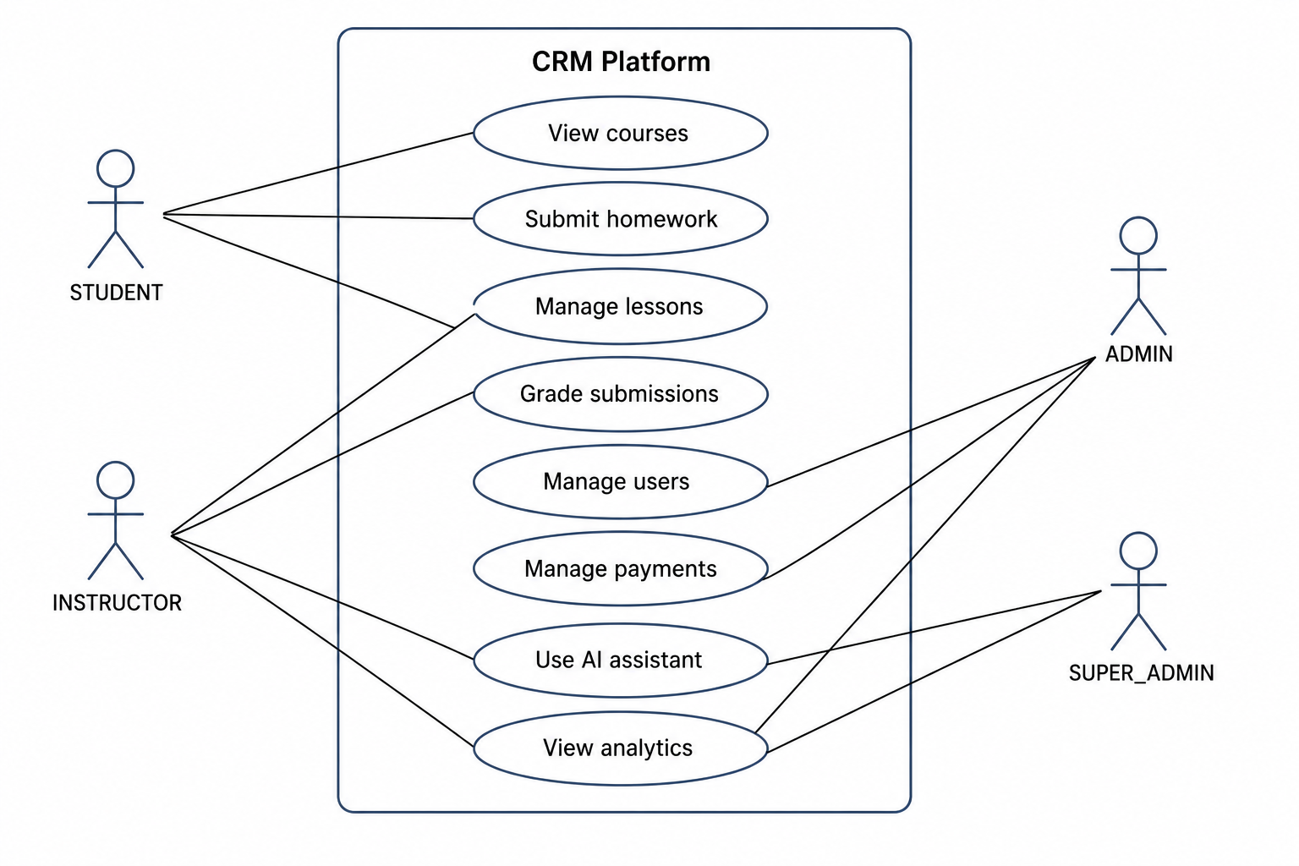

Figure 2.1 – Use case model of the CRM platform

For the student, the key use cases include viewing personal profile information, accessing enrolled courses, checking the lesson schedule, downloading materials, submitting homework, viewing grades and receiving notifications. The student can also use the AI assistant to ask questions about platform navigation, course information or learning-related tasks. This role is focused on participation, access to information and support.
For the instructor, the main use cases include managing lessons, adding materials, creating homework assignments, reviewing submissions, providing grades and feedback, marking attendance and analysing student progress. The instructor can also use the AI assistant as a support tool, for example to clarify course-related information or assist with routine educational communication. In this way, the instructor role combines educational, organisational and evaluative responsibilities.
For the administrator, the system provides functionality for user management, course administration, student enrolment, payment tracking and monitoring of platform activity. This role is responsible for maintaining the organisational structure of the system and ensuring that learning processes are correctly configured. The administrator does not directly participate in every lesson, but supports the conditions under which courses, instructors and students can interact effectively.
The super administrator has the broadest set of permissions. This role can perform all administrative actions and manage higher-level configuration, including role assignment and system-level control. In a real organisation, this role would normally be assigned to a limited number of trusted users, since it provides access to sensitive platform settings.
Table 2.2 summarises the relationship between user roles, key use cases and the corresponding functional areas of the platform.

Table 2.2 – User roles, key use cases and functional areas of the platform
User role | Key use cases | Main functional areas
STUDENT | View enrolled courses, access lessons and materials, submit homework, view grades, receive notifications, use AI assistant | Courses, lessons, materials, homework, grades, notifications, AI assistant
INSTRUCTOR | Manage lessons, upload materials, create homework, grade submissions, mark attendance, view progress, use AI assistant | Lessons, materials, homework, attendance, analytics, AI assistant
ADMIN | Manage users, enrol students, configure courses, manage payments, monitor dashboard indicators | User management, enrolment, courses, payments, dashboard
SUPER_ADMIN | Perform all administrative actions, manage roles and system-level settings | All modules and system configuration

Role-based access is implemented through authentication and authorisation mechanisms. After successful login, the user receives authentication tokens, and the backend validates access to protected endpoints according to the assigned role. On the frontend side, role information is used to display the appropriate navigation menu and available pages. This combination of backend and frontend access control ensures that restrictions are applied both at the user interface level and at the API level.
The role-based design also affects the AI assistant. Since different users have different access rights, the AI assistant must not receive the same context for all roles. For example, a student may receive assistance based on their own courses and assignments, while an instructor may receive support related to the courses they teach. An administrator may work with broader operational information, but even in this case the assistant should only use data that is relevant and allowed for the current task. This makes role-based access an important part not only of system security, but also of AI governance.
Thus, the use case model defines the functional boundaries of each user role and prepares the basis for the architectural design of the platform. It ensures that the system is not a generic application with identical access for all users, but a structured CRM environment adapted to the real responsibilities of learners, instructors and administrators.

2.4 System architecture and main functional modules

The CRM platform is designed using a client-server architecture with a clear separation between the frontend, backend, database, file storage and external services. This architectural style is suitable for a web-based educational CRM system because it allows users to access the platform through a browser, while the core business logic and data processing remain concentrated on the server side. It also supports future extensibility, since new clients, integrations or services can be added without fully redesigning the system.
The frontend part of the system is implemented as a single-page application. Its main responsibility is to provide user interfaces for students, instructors and administrators. It communicates with the backend through REST API requests and displays data according to the role of the authenticated user. The frontend contains role-specific pages, shared interface components, authentication logic and state management. This separation allows the user interface to remain flexible while relying on the backend for business rules and data consistency.
The backend part of the platform is implemented as a Spring Boot application. It exposes REST API endpoints, processes user requests, applies security rules, performs business logic and communicates with the database and external services. The backend follows a layered structure that includes controllers, services, repositories and domain entities. Controllers receive HTTP requests and return responses. Services contain the main business logic. Repositories provide access to persistent data. Domain entities represent the main objects of the system, such as users, courses, lessons, homework and submissions.
The database is responsible for storing structured platform data. It contains information about users, roles, courses, enrolments, lessons, materials, homework, submissions, attendance records, payments, notifications and AI conversations. Since the platform is CRM-oriented, the database must not only store separate educational records, but also preserve the relationships between them. For example, a learner is connected to courses through enrolments, to lessons through attendance, to homework through submissions and to AI support through conversation history.
File storage is separated from the relational database. Learning materials, profile photos and other uploaded files are stored in object storage. This design avoids overloading the database with large binary data and makes file management more flexible. The database stores only metadata and links related to uploaded files, while the files themselves are stored externally.
External services extend the functionality of the platform. The AI assistant subsystem communicates with an external AI/LLM provider through an API. Telegram integration is used for external notifications, while e-mail can be used for verification and user communication. These integrations are not implemented directly in the frontend; instead, they are controlled by backend services. This ensures that external communication follows platform rules and that sensitive data is not exposed unnecessarily.
At the module level, the platform can be divided into several functional areas. The Authentication and Security module manages registration, login, e-mail verification, token generation and access control. It forms the entry point to the system and protects all role-specific functionality (Fig 2.2).

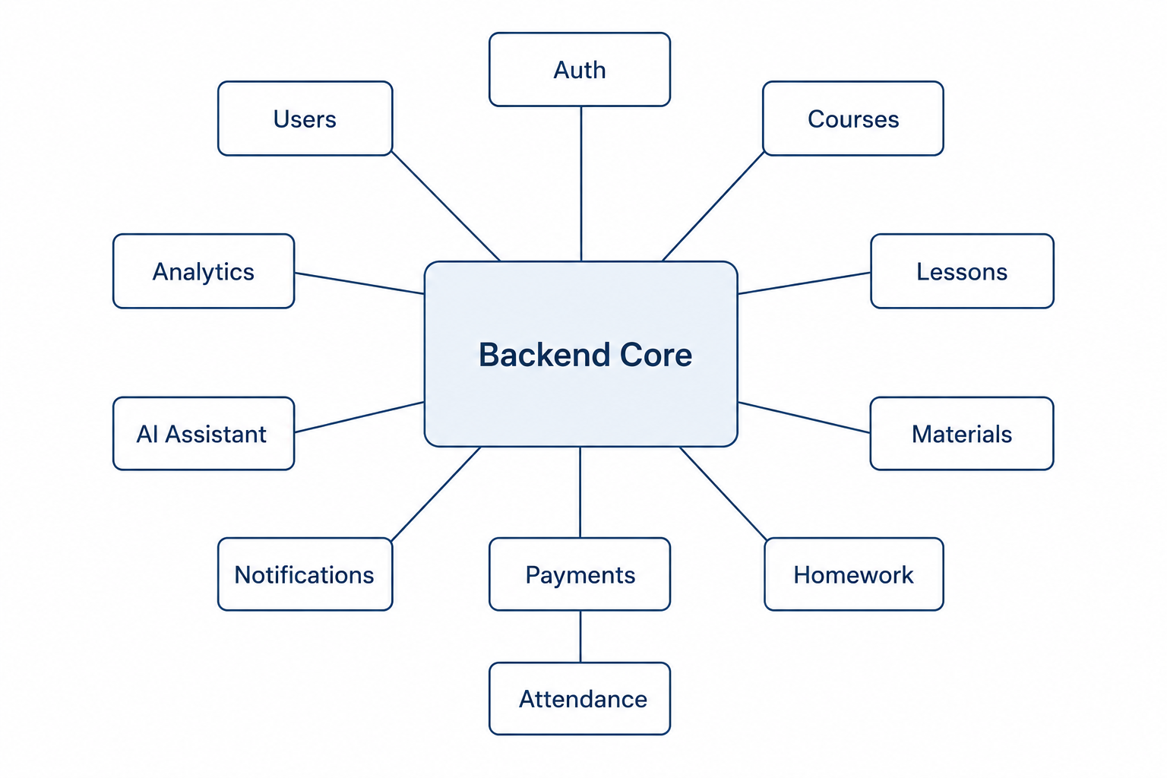

Figure 2.2 – Functional module structure of the CRM platform

The User and Profile Management module stores and updates user information. It supports profile editing, user activation or deactivation, password management and profile photo upload. Since all platform roles are based on users, this module is one of the central parts of the system.
The Course and Enrolment modules define the educational structure of the platform. Courses represent training programmes or learning units, while enrolments connect students with courses. This connection makes it possible to track which learners participate in which courses and to calculate progress indicators.
The Lesson Management module supports the planning and organisation of educational sessions. It includes lesson titles, descriptions, dates, statuses and recording links. Lessons are connected to courses and provide the structure for materials, attendance and homework activities.
The Material Management module allows instructors to upload and attach learning resources to lessons. These materials may include documents, presentations, archives or links. The module works together with file storage and ensures that students can access the resources related to their enrolled courses.
The Homework and Submission module supports assignment creation, submission by students and evaluation by instructors. It includes deadlines, submission links or files, grades and feedback. This module is important for measuring learning outcomes and connecting educational activities with learner progress.
The Attendance module records participation in lessons. It allows instructors to mark students using predefined attendance statuses. Attendance data can later be used in analytics, progress tracking and reports.
The Payment module stores payment-related rules and records. Although the platform is primarily educational and CRM-oriented, payment information is important for training centres and corporate learning providers where courses may be connected with financial obligations.
The Notification module provides communication between the system and users. Notifications may inform users about new lessons, homework deadlines, grades, payment updates or other important events. Telegram integration extends this functionality beyond the web interface.
The AI Assistant module provides conversational support. It receives user messages, prepares controlled context, sends requests to the external AI provider and stores conversation history. This module is closely connected with role-based access and platform data because the usefulness and safety of AI responses depend on what context is provided.
Finally, the Analytics and Reporting module aggregates data from other modules and presents indicators related to enrolment, attendance, homework, grades and activity. This module supports administrators and instructors in monitoring the effectiveness of training processes.
Overall, the architecture of the platform reflects the main design goal of the project: to combine training management, CRM-oriented learner tracking and AI-assisted support in a single coherent system. The modular structure makes the system easier to understand, test and extend, while the separation between frontend, backend, database, file storage and external services supports maintainability and future development.

2.5 Database design and core diagrams of the platform

Database design is one of the most important parts of the CRM platform because the system is built around structured information about users, courses, learning activities and interactions. If the database is poorly organised, the platform cannot provide a reliable learner profile, consistent access control, accurate analytics or meaningful AI context. Therefore, the database model must reflect both the educational logic of the platform and its CRM-oriented purpose.
The core design principle is that the learner should be represented as part of a broader relationship structure. A learner is not only a user with login credentials. A learner is connected to courses, lessons, submissions, attendance records, payments, notifications and AI conversations. These relationships allow the platform to reconstruct the learner’s training path and provide a more complete view of their participation. (Fig 2.3)

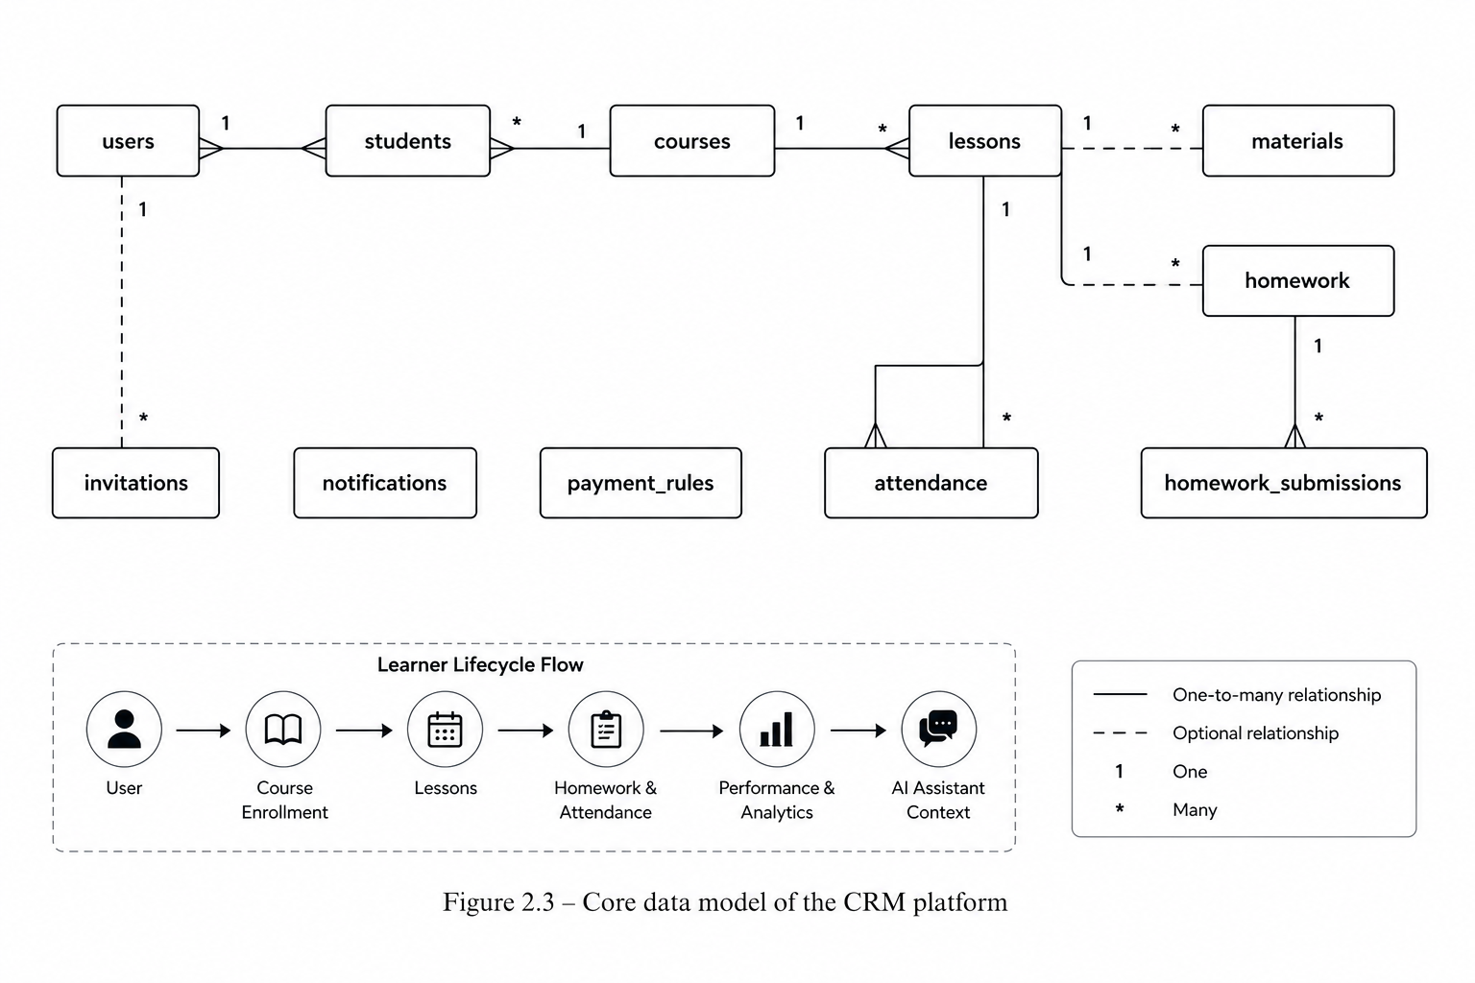

Figure 2.8 – Learner-centered data model

The database is designed as a relational model because the platform includes many structured entities with clear and stable relationships. The CRM platform for training operates with data that has a logical structure: users, roles, courses, lessons, materials, homework, submissions, attendance, payments, notifications and AI conversations. These entities are not isolated from each other; they form a connected data model that reflects the main business processes of the system. For this reason, a relational database is suitable for the project, as it allows the platform to store structured information, define relationships between records and ensure data consistency through constraints.
Users are one of the central entities of the system. They are connected with roles, profiles and platform permissions. Depending on the role, a user may act as a student, instructor, administrator or super administrator. This role-based structure influences both the business logic of the platform and the way data is accessed. For example, an instructor is connected with the courses they teach, while a student is connected with the courses in which they are enrolled. Administrators, in turn, manage users, courses, payments and other operational data.
Courses are connected with instructors and students. Each course contains basic information, such as its title, description, dates, assigned instructor and status. Students are connected with courses through enrolment records. This makes it possible to track which learners participate in which programmes and prevents confusion when one learner is enrolled in several courses at the same time. The enrolment entity also helps the system represent the learner lifecycle more accurately, because it shows the learner’s participation in a specific course or programme.
Lessons belong to courses and represent the scheduled educational activities within a programme. A course may contain multiple lessons, and each lesson may have its own date, topic, materials, attendance records and homework assignments. This structure allows the system to organise the learning process step by step. Materials are attached to lessons or courses so that learners can access the necessary resources in the correct context. For example, a lesson may include a presentation, a document, a video link or another type of learning material.
Homework assignments are connected to lessons or courses, while homework submissions are connected to both students and homework tasks. This relationship is important because one homework assignment can be given to many students, but each student has their own submission, status, grade and feedback. Such a structure allows instructors to track who has submitted the task, evaluate each submission individually and provide feedback. It also allows students to view their own submissions, grades and comments.
Attendance records connect students with lessons. This table is necessary because attendance is not simply a property of a student or a lesson; it is a relationship between a specific student and a specific lesson. For example, one student may attend one lesson and miss another, while another student may have a different attendance history. A separate attendance entity makes it possible to store attendance status, date of recording and additional comments if needed.
Payments connect students with courses, payment rules or payment records. This part of the database supports the administrative side of training management. It allows authorised users to record payment status, payment amounts, due dates or related financial information. Even if the prototype does not include a full online payment gateway, the presence of payment records in the database is important because many training organisations need to coordinate enrolment, access and financial status within one system.
Notifications and AI conversations connect system events with specific users. Notifications may be generated when a new lesson is created, homework is assigned, a grade is published or an important administrative update is sent. AI conversations are connected with users in order to store interaction history and provide continuity of support. This is important because the AI assistant is not treated as a separate external chatbot, but as part of the platform’s communication and learner support process.
The database design also supports security and data consistency. Foreign keys are used to preserve relationships between entities and prevent invalid references. For example, a lesson cannot be correctly stored without being connected to an existing course, and a homework submission should refer to an existing homework assignment and an existing student. This protects the database from inconsistent or incomplete records.
Unique constraints are used to prevent duplicate records where necessary. For example, a student should not be enrolled in the same course twice. Similarly, authentication-related fields such as e-mail should remain unique, because each user account must be clearly identifiable. Unique constraints also help reduce errors in administrative processes and ensure that important records remain logically correct.
Status fields are used to represent the lifecycle of different records. For users, statuses may indicate whether an account is active, inactive or pending verification. For courses, statuses may show whether a course is planned, active, completed or archived. For lessons, statuses may describe whether a lesson is scheduled, completed or cancelled. For homework, statuses may indicate whether a task is created, submitted, checked or graded. These status fields make it possible to manage data not only as static records, but as objects that move through different stages.
The relational database model also supports reporting and analytics. Since the data is structured and connected, the system can generate reports about course participation, attendance, homework completion, grades, payments and user activity. For example, administrators can analyse the number of enrolled students, instructors can monitor submission rates, and managers can evaluate the overall state of training processes. This would be much more difficult if the same data were stored in disconnected spreadsheets, messengers or files.
In addition to the database schema, several diagrams are used to describe the platform. These diagrams help explain the system from different perspectives and make the design easier to understand. Since the platform includes several user roles, functional modules and technical components, diagrams are necessary to visualise how the system works at different levels.
A use case diagram shows how user roles interact with platform functions. It demonstrates which actions are available to students, instructors, administrators and super administrators. For example, students can view courses, access materials, submit homework and use the AI assistant. Instructors can manage lessons, upload materials, check homework and record attendance. Administrators can manage users, courses, enrolments, payments and notifications. This diagram helps connect functional requirements with user responsibilities.
A database or ER diagram shows the main entities and relationships of the platform. It visualises how users, courses, lessons, homework, submissions, attendance, payments, notifications and AI conversations are connected. The ER diagram is especially important because it translates the conceptual understanding of the subject area into a concrete data structure. It also helps identify primary keys, foreign keys and relationship types between entities.
A sequence diagram describes the order of actions in important scenarios. For example, in the homework submission scenario, the student opens the homework task, uploads or submits the answer, the frontend sends the request to the backend, the backend validates the user and the task, stores the submission in the database and returns the result to the user. In the AI assistant interaction scenario, the user sends a message, the backend checks the user role, prepares limited context, sends the request to the AI provider, receives the response, stores the conversation and displays the answer to the user.
A deployment diagram explains how the system components are placed in the deployment environment. It shows the frontend, backend, database, file storage, AI provider and notification integrations. This diagram is important because the platform is not only a database and application code, but a set of components that must work together in a production-like environment. It also helps explain how the system can be deployed using Docker, Docker Compose and cloud infrastructure.

Together, the database model and diagrams provide a bridge between the conceptual design of the platform and its practical implementation. They show how the requirements described in Section 2.2 are transformed into concrete structures, relationships and technical interactions. The database model defines how information is stored and connected, while diagrams explain how users, modules and infrastructure interact with each other.
Thus, database design and system diagrams play an important role in the development of the CRM platform for training with an integrated AI assistant. They help ensure that the system is logically organised, technically consistent and aligned with the functional requirements of the project. They also provide a foundation for implementation, testing and future extension of the platform.

2.5.1 Physical database schema and main entities

The physical database schema represents the main data entities of the CRM platform and their relationships. It is implemented in PostgreSQL and managed through database migration scripts. This approach makes the database structure versioned and controlled, which is important for reliable development and deployment.
The central entity of the system is the users table. It stores account and profile information for all types of users, including students, instructors, administrators and super administrators. The table includes fields such as identifier, e-mail, password hash, first name, last name, role, status, phone, profile photo reference and timestamps. This design allows all user roles to be represented within one common identity model, while role-based access determines what each user can do in the system.
The courses table represents training programmes or courses offered through the platform. A course includes its name, description, instructor reference, start and end dates, number of lessons and other configuration fields. Courses form the main organisational unit of the educational process.
The relationship between students and courses is represented through the enrolments or students table, depending on the specific implementation naming. This entity connects a user with a course and stores additional indicators such as enrolment status, average grade, attendance rate or homework completion rate. Such a structure is important because the same student may participate in several courses, and each participation record may have its own progress indicators.
The lessons table stores individual educational sessions within a course. Each lesson has a title, description, date and time, status, course reference and optional recording link. Lesson status makes it possible to distinguish between scheduled, completed and cancelled lessons. Lessons serve as the connection point for materials, attendance and homework.
The materials table stores metadata about learning resources. The actual files are stored in object storage, while the database stores file names, file types, URLs or storage keys, and references to related lessons. This separation improves performance and keeps the database focused on structured data.
The homework table represents assignments created by instructors. It contains assignment title, description, deadline, course or lesson reference and status information. The homework_submissions table stores student submissions, including submission content, file or link references, submission time, grade and instructor feedback. This two-level structure separates the assignment itself from individual student responses.
The attendance table records student participation in lessons. Each record connects a student with a lesson and stores an attendance status, such as present, absent, late or excused. This allows instructors and administrators to monitor participation and calculate attendance-based indicators.
The payments or payment-related tables store financial records connected with courses and students. They may include payment rules, amounts, due dates, statuses and payment history. This functionality is especially relevant for training centres and private educational organisations.
The notifications table stores messages generated by the system for users. Notifications may be related to lesson updates, homework deadlines, grades, payments or system events. If Telegram integration is enabled, notifications may also be sent outside the platform.
The AI conversation entities store records of user interaction with the AI assistant. They include the user identifier, message content, response content, timestamps and possibly metadata about the type of request. Storing these records is useful for transparency, support analysis and future improvement of the assistant.
The main entities of the database can be grouped as follows:
- identity and access entities: users, roles, verification and authentication-related records;
- educational entities: courses, lessons, materials, homework and submissions;
- learner progress entities: enrolments, grades, attendance and completion indicators;
- operational entities: payments, notifications and file metadata;
- AI-related entities: conversations, messages and context-related records.
This database structure supports both the educational and CRM dimensions of the platform. It allows the system to manage learning processes while also maintaining a unified and historically meaningful view of learner activity.

2.5.2 Use case, sequence and deployment

The structural and behavioural aspects of the CRM platform are described through three complementary views: the use case model, the sequence of key interactions and the deployment model. These views make it possible to explain the system not only as a set of database entities, but also as a working software environment where users, modules and infrastructure components interact with each other.
The use case model (Fig 2.4) defines the functional boundaries of the platform from the perspective of its main user roles. The system supports four primary roles: STUDENT, INSTRUCTOR, ADMIN and SUPER_ADMIN. Each role has access to a specific set of actions that corresponds to its responsibilities in the training management process.

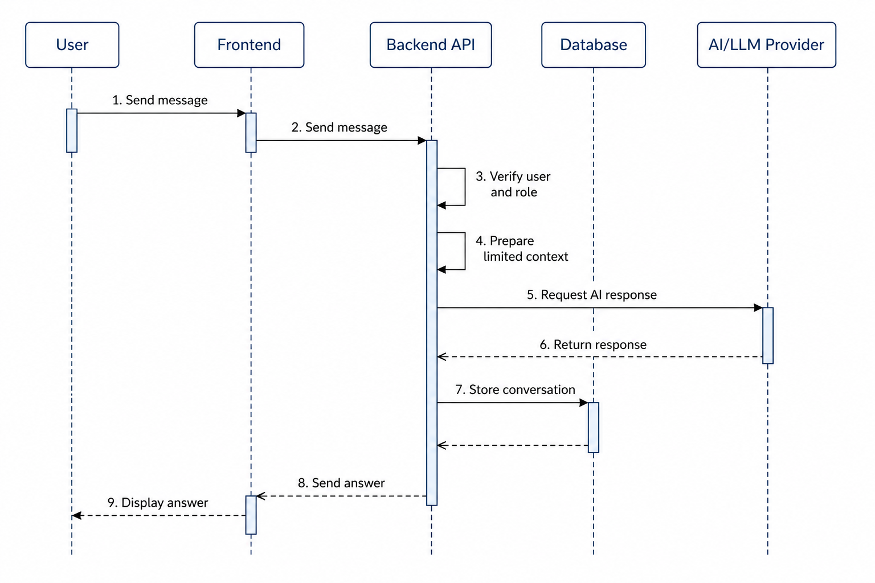

Figure 2.4 – Sequence diagram of AI assistant interaction

The STUDENT role is focused on participation in the learning process. A student can view enrolled courses, access lessons and materials, submit homework, view grades, receive notifications and use the AI assistant for platform-related or learning-related support. This role represents the learner’s direct interaction with the educational process.
The INSTRUCTOR role is responsible for organising and monitoring learning activities. An instructor can manage lessons, upload materials, create homework assignments, review submissions, provide grades and feedback, mark attendance, view progress indicators and use the AI assistant as a support tool. This role connects educational content, assessment and learner progress tracking.
The ADMIN role is responsible for operational management of the platform. An administrator can manage users, configure courses, enrol students, manage payment records and monitor dashboard indicators. This role supports the organisational side of the training process and ensures that courses, instructors and students are correctly connected within the system.
The SUPER_ADMIN role has the broadest level of access. It includes administrative functionality as well as system-level control, such as role management and global configuration. This role is intended for a limited number of trusted users because it provides access to sensitive platform settings and high-level management operations.
The separation of use cases by roles supports both usability and security. From the usability perspective, each user sees only the functions that are relevant to their tasks. From the security perspective, access to sensitive data and operations is limited according to the assigned role. This is especially important for the CRM platform because it stores personal data, educational records, payment information and AI interaction history.
The behavioural logic of the platform can be demonstrated through the AI assistant interaction flow. The process begins when an authenticated user sends a message through the platform interface. The frontend transfers the request to the backend API, where the system verifies the user identity and role. After successful verification, the backend prepares a limited context based on the user’s permissions and the current request. This context may include selected course, lesson, homework or platform-related information, but it does not provide unrestricted access to all system data.
After the context is prepared, the backend sends the request to the external AI/LLM provider. The response is returned to the backend, where it can be processed, stored and associated with the user’s conversation history. Only after this step is the generated answer returned to the frontend and displayed to the user. This flow ensures that the AI assistant remains integrated into the platform logic rather than functioning as a separate external chatbot.
This approach has several advantages. First, the frontend does not communicate directly with the AI provider, which protects API keys and internal integration logic. Second, the backend controls which data can be passed to the AI model. Third, AI conversations can be stored for transparency, support analysis and future improvement of the assistant. As a result, the AI assistant becomes a controlled platform module connected with authentication, authorisation and data governance.
The deployment model describes how the platform components are organised in the runtime environment. The system consists of a frontend application served through Nginx, a Spring Boot backend application, a PostgreSQL database and MinIO object storage. These components are deployed as separate services, which makes the system easier to configure, maintain and scale.
The frontend service is responsible for delivering the user interface to students, instructors and administrators. Nginx serves the built React application and routes user requests to the appropriate frontend resources. The backend service contains the business logic of the platform, including authentication, role-based access control, course management, lesson management, homework processing, attendance tracking, payment records, notifications and AI assistant integration.
PostgreSQL is used for structured data storage. It stores users, courses, enrolments, lessons, materials metadata, homework, submissions, attendance, payments, notifications and AI conversation records. MinIO is used for object storage and keeps uploaded files such as profile photos, learning materials and homework-related documents. This separation allows the database to remain focused on structured records, while file content is stored in a more suitable storage system.
External services are accessed through backend-controlled integration points. The AI/LLM provider is used for conversational support, the Telegram Bot API is used for external notifications, and the e-mail service is used for verification and communication scenarios. Since these integrations are handled by the backend, sensitive credentials and business rules are not exposed to the client side.
The use case model, AI interaction flow and deployment model together provide a complete architectural view of the platform. The use case model explains how different categories of users interact with the system. The sequence flow shows how one of the most important interactions, communication with the AI assistant, is processed. The deployment model explains how the software components are organised in the technical environment. Together, these views connect the database design with the practical implementation of the CRM platform.

2.6 Technology stack selection and comparison of technologies

The selection of the technology stack is an important design decision because it directly influences the maintainability, scalability, security and practical feasibility of the CRM platform. Since the developed system is intended to manage training processes, user roles, educational data, files, notifications and AI-assisted interaction, the selected technologies must support both reliable backend processing and convenient user interaction on the frontend side. The technology stack also has to be realistic for a diploma project, meaning that it should allow the imple mentation of a working prototype within limited time and resources. (Fig 2.5)
The platform is designed as a web-based client-server application. The frontend is implemented as a single-page application, while the backend provides REST API endpoints for all core operations. This separation makes the system more flexible because the frontend and backend can be developed, tested and deployed independently. It also supports further development, for example the creation of a mobile application or additional external integrations using the same backend API.
For the backend part, Java 21 and Spring Boot were selected. Java is a mature programming language widely used in enterprise application development. It provides strong typing, a large ecosystem of libraries and stable long-term support. Spring Boot simplifies the creation of web applications by providing ready-made mechanisms for dependency injection, REST controllers, configuration, security, validation and database access. In the context of this project, Spring Boot is suitable because the platform contains many business entities, requires role-based access control and needs integration with external services such as file storage, e-mail, Telegram and an AI provider.
For database management, PostgreSQL was selected. PostgreSQL is a reliable relational database management system that supports structured data, constraints, indexes, transactions and complex relationships between entities. This is important for the CRM platform because the system stores users, courses, enrolments, lessons, homework, attendance, payments, notifications and AI conversations. A relational model is appropriate for such data because many entities are connected through clear relationships and require consistency.
For database versioning and controlled schema evolution, Flyway is used. Instead of relying on automatic schema generation in production-like environments, Flyway allows every database change to be described as a migration script. This makes the database structure predictable and traceable. In combination with Hibernate validation mode, it helps ensure that the application entities and the actual database schema remain consistent.

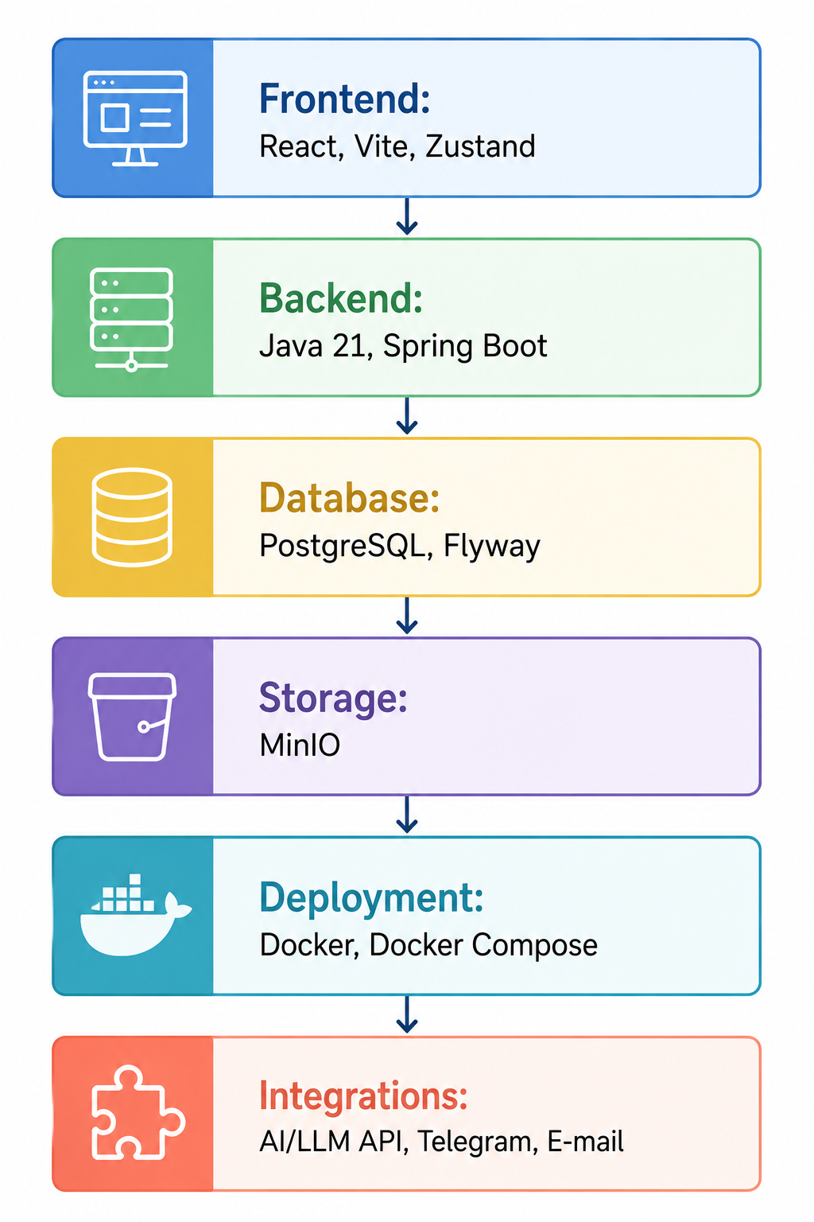

Figure 2.12 – Technology stack of the CRM platform

For the frontend part, React was selected. React is a widely used JavaScript library for building dynamic user interfaces. It is suitable for a role-based platform because it allows the interface to be divided into reusable components and pages. This is important for the project, since students, instructors and administrators need different screens and workflows. React also works well with modern frontend tools and supports the development of responsive and interactive interfaces.
The frontend is built using Vite, which provides fast project startup, efficient development mode and optimised production builds. For state management, Zustand is used. This library provides a simple and lightweight mechanism for storing shared frontend state, such as authentication data and user information. Compared with more complex state management tools, Zustand is easier to configure and sufficient for the needs of the prototype.
For file storage, MinIO was selected. The platform needs to store profile photos, learning materials and possibly homework-related files. Storing such files directly in the relational database would be inefficient. MinIO provides object storage compatible with the S3 model and can be deployed locally or in a containerised environment. This makes it suitable for a diploma prototype and future production-like deployment.
For deployment and environment configuration, Docker and Docker Compose are used. Containerisation allows the frontend, backend, database and file storage to be launched as separate services with defined configurations. This improves reproducibility and simplifies deployment, because the system environment can be described in configuration files rather than manually assembled on each machine.
The AI assistant is integrated through an external AI/LLM provider using API-based communication. In this project, the backend acts as an intermediary between the frontend and the AI provider. This design protects API keys, allows context control and ensures that AI conversations can be logged. Direct communication between the frontend and the AI provider is avoided for security and governance reasons.
Table 2.3 summarises the main selected technologies and their role in the platform.

Table 2.3 – Selected technology stack and its role in the CRM platform
Technology | Role in the system | Reason for selection
Java 21 | Backend programming language | Stability, strong typing, enterprise ecosystem
Spring Boot | Backend framework | REST API, security, services, integration support
PostgreSQL | Relational database | Data consistency, relationships, transactions
Flyway | Database migrations | Controlled and versioned schema evolution
React | Frontend library | Component-based user interface and role-based screens
Vite | Frontend build tool | Fast development and optimised build process
Zustand | Frontend state management | Lightweight authentication and UI state handling
MinIO | Object storage | File storage for materials and profile photos
Docker / Docker Compose | Deployment environment | Reproducible multi-service deployment
External AI/LLM API | AI assistant provider | Natural language support without training a custom model

The selected technologies were also compared with possible alternatives. For the backend, alternatives such as Node.js with Express or NestJS could also be used. However, Spring Boot was selected because it provides a more structured enterprise-style environment, strong security support and convenient integration with relational databases. For the frontend, alternatives such as Angular or Vue could be considered. React was selected because it offers flexibility, a large ecosystem and convenient component-based development. For the database, MySQL could also satisfy many requirements, but PostgreSQL provides strong support for relational modelling, constraints and future analytical extensions.
The selected stack reflects the needs of the project: reliable backend logic, structured data management, interactive frontend interface, controlled file storage, containerised deployment and AI integration. At the same time, the technologies are not excessive for the prototype and can be used in a real development environment. Therefore, the chosen stack provides a practical balance between academic feasibility and production-oriented design.

3 IMPLEMENTATION, TESTING AND DEPLOYMENT OF THE SYSTEM

After defining the design and architecture of the CRM platform, the next stage of the diploma project is the implementation, testing and deployment of the system. This chapter describes how the architectural decisions presented in Chapter 2 were transformed into a working software prototype. The implementation covers the backend application, frontend interface, database configuration, file storage, AI assistant integration and deployment environment.
The main purpose of the implementation stage is to demonstrate that the proposed design can be realised as a functioning platform. The system is not limited to a theoretical architecture; it includes practical modules for authentication, user management, courses, lessons, materials, homework, attendance, payments, notifications, analytics and AI-assisted interaction. These modules together form the core of the CRM platform for training.
The implementation follows the client-server model described in Chapter 2. The backend is responsible for business logic, data access, security and integration with external services. The frontend provides role-based interfaces for students, instructors and administrators. PostgreSQL stores structured platform data, while MinIO is used for files. The AI assistant is integrated through backend-controlled API communication with an external AI/LLM provider.
Testing and validation are also important parts of this chapter. Since the platform supports several roles and business processes, it is necessary to verify that the main scenarios work correctly. These scenarios include user registration and login, course creation, enrolment, lesson management, material upload, homework submission, grading, attendance marking, notification delivery and AI assistant interaction. In addition to functional correctness, the system is also evaluated in terms of usability, reliability, role-based access and deployment readiness.
The chapter is organised according to the practical development flow. Section 3.1 describes the project structure and backend implementation. Section 3.2 presents the frontend and user interface implementation. Section 3.3 explains database configuration, migrations and file storage. Section 3.4 describes the AI assistant and external integrations. Section 3.5 presents testing and validation results. Section 3.6 discusses deployment, limitations and further development.

3.1 Project structure and implementation of the backend

The backend of the CRM platform is implemented as a Spring Boot application. It provides the central business logic of the system and exposes REST API endpoints that are consumed by the frontend. The backend is responsible for user authentication, role-based authorisation, data processing, validation, interaction with the database, file-related operations and communication with external services. Because the platform includes several functional modules, the backend project is organised in a layered and modular way.
The general backend structure follows common Spring Boot development principles. The application is divided into packages that separate configuration, controllers, services, repositories, entities, DTOs, security components and integrations. This separation improves maintainability because each layer has a clear responsibility. Controllers handle HTTP requests and responses, services contain business logic, repositories communicate with the database, entities represent persistent data, and DTOs are used to transfer data between the backend and frontend.
At the entry point of the backend, REST controllers define the API of the platform. Each major functional area has its own controller or group of endpoints. For example, authentication endpoints are used for registration, login, token refresh and e-mail verification. User endpoints support profile management and administrative user operations. Course endpoints provide course creation, editing and retrieval. Lesson endpoints support scheduling and lesson status management. Homework and submission endpoints allow instructors to create assignments and students to submit their work.
The service layer contains the main business rules of the platform. For example, when a student submits homework, the service layer verifies that the student is enrolled in the corresponding course, checks whether the homework exists and processes the submission data. When an instructor marks attendance, the service checks the lesson, student and permission context before saving the record. This prevents important business logic from being placed directly in controllers and keeps the API layer cleaner.
The repository layer is implemented using Spring Data JPA. Repositories provide database access for entities such as users, courses, lessons, homework, submissions, attendance and notifications. This approach reduces the amount of repetitive SQL code and allows standard operations such as save, find, update and delete to be performed through repository interfaces. At the same time, custom queries can be added when more specific filtering or aggregation is required.
Authentication and security are implemented through Spring Security and JWT-based access control. After login, the user receives an access token that is used for authenticated requests. The backend validates the token, extracts the user identity and checks the user’s role before allowing access to protected endpoints. This mechanism is essential for the platform because different roles have different permissions. For example, a student cannot access administrative user management, while an instructor cannot perform system-level configuration.
The backend uses DTOs to avoid exposing internal entity structures directly through the API. Request DTOs are used for receiving input from the frontend, while response DTOs are used for returning structured data. This design is important because entities often contain internal fields, relationships or sensitive data that should not be exposed. DTOs also make it possible to shape responses according to frontend needs without changing the database model.
Validation is applied to incoming requests to prevent incorrect or incomplete data from entering the system. For example, registration requires valid e-mail and password data, course creation requires basic course information, homework creation requires a deadline and description, and payment records require amount and status information. Validation improves reliability and reduces the risk of inconsistent records.
The backend implementation includes several core modules. The authentication module provides registration, login, token generation, token refresh and e-mail verification. The user module manages user profiles and administrative user operations. The course module implements the creation and management of training courses. The enrolment module connects students with courses and supports progress-related indicators. The lesson module manages lesson schedules and statuses. The homework module supports assignments, submissions, grades and feedback. The attendance module stores lesson participation records. The payment module manages payment rules and records. The notification module handles system notifications and external notification integration. The AI assistant module processes user messages and communicates with the external AI provider.
The backend also includes configuration components for database access, file storage, security and external API communication. These configuration classes make it possible to keep environment-specific settings outside the business logic. For example, database connection parameters, MinIO credentials, AI provider API keys and e-mail settings can be passed through environment variables. This approach is important for deployment because the same application can be launched in different environments without changing source code.
The implementation of the backend demonstrates the transformation of the architectural model into practical software components. The layered structure ensures that responsibilities are separated, while the modular organisation reflects the functional areas of the CRM platform. As a result, the backend provides a stable foundation for the frontend interface, database operations, AI assistant integration and future system expansion.

3.2 Implementation of the frontend and user interface

The frontend part of the CRM platform is implemented as a React-based single-page application. Its main purpose is to provide convenient access to the platform functionality for different user roles and to present complex training management processes through a clear and structured interface. Since the system is used by students, instructors and administrators, the frontend is designed around role-based navigation and role-specific pages.
The frontend communicates with the backend through REST API requests. After authentication, the application stores the user’s access data in the frontend state and uses it to display the appropriate interface. This means that the student, instructor and administrator do not see the same set of pages. Instead, each role receives access to the functions that correspond to their responsibilities in the training process.
The implementation of the frontend follows a component-based structure. Shared interface components are reused across different pages, while role-specific pages are organised separately. This makes the user interface more maintainable because repeated elements, such as buttons, forms, tables, cards, modal windows and navigation blocks, are not implemented from scratch for every screen. At the same time, each role can have its own workflow and visual structure.
The student interface is focused on access to learning activities. After logging into the system, the student can view enrolled courses, open course details, check lessons, access materials, submit homework, review grades and receive notifications. The AI assistant is also available as a support tool that helps the student ask questions about the platform, course information and learning-related processes.
The instructor interface is designed for educational process management. The instructor can view assigned courses, create and manage lessons, upload materials, create homework assignments, check submissions, give grades and feedback, and mark attendance. This interface is more operational than the student interface because instructors perform more management actions. Therefore, the frontend provides forms, tables and action buttons that allow instructors to work with educational data efficiently.
The administrator interface provides tools for platform management. It includes pages for managing users, courses, enrolments, payments and dashboard indicators. The administrator can create and update user accounts, assign roles, enrol students in courses and monitor general platform activity. The dashboard provides aggregated information and supports operational control of the training process.
The main frontend modules include:
- authentication pages for login, registration and verification;
- role-based dashboard pages;
- user profile and account settings;
- course catalogue and course details;
- lesson management pages;
- material upload and access pages;
- homework and submission pages;
- attendance management pages;
- payment and notification pages;
- AI assistant interface;
- administrative management pages.
State management is implemented with a lightweight store approach. The authentication state stores information about the current user, access token and role. This state is used by route protection logic and by the interface to determine which pages should be visible. If the user is not authenticated, protected pages are unavailable. If the user has a role that does not match the required access level, the interface prevents navigation to restricted sections.
The user interface is designed to make the platform understandable for non-technical users. Important information is presented through cards, tables and structured sections. For example, course information is shown as a list or card-based view, lesson data is displayed with dates and statuses, homework pages include deadlines and submission states, and dashboard pages present aggregated indicators. This visual organisation helps users understand their current tasks and available actions.
Table 3.1 summarises the main frontend areas and their purpose.

Table 3.1 – Main frontend areas and their purpose
Frontend area | Main users | Purpose
Authentication pages | All users | Login, registration, verification and access to the platform
Student dashboard | STUDENT | Overview of enrolled courses, lessons, homework and notifications
Instructor workspace | INSTRUCTOR | Management of lessons, materials, homework, attendance and grading
Admin dashboard | ADMIN, SUPER_ADMIN | User management, enrolments, payments and platform monitoring
Course and lesson pages | STUDENT, INSTRUCTOR, ADMIN | Access to course structure, schedules and educational activities
AI assistant interface | STUDENT, INSTRUCTOR | Conversational support inside the platform
Profile settings | All users | Management of personal information and profile photo

The frontend implementation is closely connected with the backend API. Each user action in the interface corresponds to a request to the backend, where business rules and access control are applied. This separation is important because the frontend is responsible for presentation and interaction, while the backend remains responsible for security, validation and data consistency.
Overall, the frontend provides a practical and role-oriented interface for the CRM platform. It transforms the backend functionality into accessible workflows and allows different users to interact with the system according to their responsibilities in the training process.

3.3 Database configuration, migrations and file storage

The database layer of the CRM platform is implemented using PostgreSQL. The database stores the structured data required for the operation of the platform, including users, roles, courses, enrolments, lessons, materials, homework, submissions, attendance records, payments, notifications and AI conversation history. Since these entities are strongly connected with each other, a relational database is suitable for the project because it provides data consistency, relationships, constraints and transactional support.
The database configuration is defined in the backend application settings. Connection parameters, including database URL, username and password, are provided through environment variables. This approach separates configuration from source code and makes the application easier to deploy in different environments. For example, the same backend application can be connected to a local PostgreSQL instance during development and to a containerised PostgreSQL service during deployment.
The project uses Flyway for database migrations. Flyway allows the database schema to be created and updated through versioned SQL scripts. Each migration script describes a specific structural change, such as creating a table, adding a column, defining an index or creating a new relationship. This approach is more reliable than automatic schema generation because every database change is explicit, traceable and repeatable.
Hibernate is configured in validation mode. This means that the application checks whether entity mappings correspond to the existing database schema, but it does not automatically create or modify tables at startup. This decision improves control over the database structure. If there is a mismatch between the Java entities and the database schema, the application fails to start, making the problem visible during development or deployment.
The migration-based approach provides several advantages:
- database changes are versioned and stored together with the project;
- the same schema can be reproduced in different environments;
- accidental changes to the database structure are avoided;
- schema evolution becomes more transparent;
- inconsistencies between application code and database structure are easier to detect.
The database schema reflects the main modules of the platform. The users table stores account and profile information. The courses table stores training course data. Enrolment-related tables connect students with courses. Lessons are connected to courses and define the schedule of the learning process. Materials are linked to lessons and contain metadata about uploaded files. Homework and submission tables support assignment workflows. Attendance records store student participation in lessons. Payment tables support financial records. Notifications and AI conversation tables store communication and support history.
File storage is implemented separately from the relational database. The platform uses MinIO object storage for files such as profile photos, learning materials and submitted documents. This architecture is more efficient than storing binary files directly in PostgreSQL. The database stores metadata about files, including file names, content types, storage keys, URLs and references to related entities. The actual file content is stored in MinIO.
When a user uploads a file, the frontend sends it to the backend. The backend validates the request, uploads the file to MinIO and saves the corresponding metadata in the database. When another user needs to access the file, the backend retrieves the metadata and provides access according to role-based permissions. For example, students can access materials related to their enrolled courses, while instructors can manage materials for their assigned courses.
The use of MinIO also supports future scalability. Since object storage is separated from the application and database, the system can handle a larger number of files without significantly increasing the size of the relational database. This is especially important for a training platform, where educational materials, homework submissions and profile images may grow over time.
The database and file storage implementation can be summarised as follows:
- PostgreSQL stores structured platform data;
- Flyway manages schema creation and updates;
- Hibernate validation checks consistency between entities and schema;
- MinIO stores uploaded files;
- the database stores file metadata and relationships;
- backend services control file upload, access and deletion.
This configuration provides a reliable foundation for the platform. Structured data remains consistent in PostgreSQL, while files are stored in an object storage system that is better suited for binary content. Together, these components support the practical operation of the CRM platform and prepare it for containerised deployment.

3.4 Implementation of the AI assistant and external integrations

The AI assistant is one of the key functional components of the CRM platform. Its purpose is to support users through natural language interaction and to make access to platform-related information more convenient. Unlike a standalone chatbot, the assistant is integrated into the platform and works with selected contextual data. This allows it to provide more relevant responses while still operating under backend-controlled restrictions.
The AI assistant is available primarily for students and instructors. A student can use it to ask questions about courses, lessons, homework, materials, deadlines or platform navigation. An instructor can use it to receive support related to course management, lesson organisation or student progress. The assistant does not replace administrators or instructors, but supports routine interaction and helps users find information faster.
The implementation of the AI assistant is based on backend-mediated communication with an external AI/LLM provider. The frontend provides the chat interface, but it does not communicate directly with the external provider. Instead, the user’s message is sent to the backend. The backend verifies authentication, checks user permissions, prepares the allowed context, sends the request to the AI provider and returns the generated response to the frontend.
This architectural decision is important for security and control. If the frontend communicated directly with the AI provider, API keys and internal logic would be exposed to the client side. In the implemented architecture, API credentials are stored on the backend side, and the system can control which data is included in the request. This also makes it possible to log conversations and analyse assistant usage.
The AI assistant is connected with several external and internal components:
- frontend chat interface;
- backend AI service;
- authentication and role-based access logic;
- database entities related to users, courses and learning activities;
- external AI/LLM provider;
- conversation history storage;
- notification or logging mechanisms.
External integrations are not limited to the AI provider. The platform also includes integrations with file storage, e-mail services and Telegram notifications. However, the AI assistant is the most complex integration because it requires not only technical API communication, but also careful context preparation and response control.

3.4.1 Integration with the external AI/LLM provider
The integration with the external AI/LLM provider is implemented through a backend service responsible for preparing requests and processing responses. When a user sends a message in the AI assistant interface, the frontend sends the message to a dedicated backend endpoint. The backend receives the request and identifies the current user through the authentication token.
After identifying the user, the backend determines the user’s role and prepares the relevant context. For a student, this context may include information about enrolled courses, upcoming lessons, homework deadlines and recent grades. For an instructor, the context may include assigned courses, lessons, submissions or attendance-related information. The exact amount of data is limited to avoid unnecessary exposure of personal or sensitive information.
The backend then creates a structured request to the external AI provider. The request includes the user’s message, system-level instructions and selected context. System-level instructions define the behaviour of the assistant, for example that it should answer only within the scope of the platform, avoid unsupported claims and recommend contacting a human administrator when the question goes beyond available information.
After the AI provider generates a response, the backend receives it and returns it to the frontend. At the same time, the system can store the conversation in the database. This includes the user message, generated response, user identifier and timestamp. The stored conversation history can later be used for audit, support analysis or improvement of the assistant.
The communication flow can be described in several stages:
- the user submits a message through the frontend chat interface;
- the frontend sends the message to the backend API;
- the backend verifies the user’s identity and role;
- the backend prepares limited contextual data;
- the backend sends the request to the external AI/LLM provider;
- the provider returns a generated response;
- the backend stores the conversation record;
- the frontend displays the response to the user.
The integration is designed so that the AI provider does not become the main decision-making component of the platform. The assistant generates text responses, but it does not directly modify critical records such as grades, payments, attendance or enrolments. Such operations remain under the control of regular backend services and authorised users. This limitation is important for preserving reliability and accountability.

3.4.2 Context passing, conversation history and response control
Context passing is the central mechanism that makes the AI assistant useful inside the CRM platform. Without context, the assistant would only be able to provide general explanations. With controlled context, it can respond to platform-specific questions and support users more effectively. However, context passing must be limited and role-aware, because the platform stores personal data and educational records.
The implemented approach is based on selective context construction. The backend does not send the entire database or unrestricted user records to the AI provider. Instead, it collects only the information that is relevant to the current user and the current request. For example, if a student asks about upcoming homework, the context may include only homework assignments from the courses in which the student is enrolled. If an instructor asks about course activity, the context may include information only about courses assigned to that instructor.
Conversation history is stored to preserve transparency and continuity. Each conversation record contains the user message, AI response, timestamp and reference to the user. Depending on the implementation, conversations may also be grouped into sessions. This makes it possible to review previous interactions and understand how the assistant was used. Conversation logging also supports future improvement, because repeated questions may indicate unclear interface elements or missing information in the platform.
Response control is implemented through several mechanisms. First, the backend controls the prompt and context sent to the AI provider. Second, role-based access determines what data can be included. Third, the assistant is instructed to answer within the scope of available information. Fourth, sensitive operations are not delegated to the AI assistant. The assistant can explain, guide and summarise, but it cannot independently change important system records.
The main safeguards include:
- limiting AI context to relevant and permitted data;
- avoiding direct frontend access to the AI provider;
- storing API keys only on the backend side;
- logging AI conversations for transparency;
- preventing the assistant from modifying critical records;
- using role-based restrictions when preparing context;
- providing fallback messages when information is unavailable.
This design makes the AI assistant a controlled support subsystem rather than an uncontrolled external chatbot. It improves the user experience by providing natural language assistance, but it preserves the platform’s security and data governance principles. As a result, the assistant supports the CRM-oriented goal of the system: improving communication, reducing routine workload and providing more contextual support to learners and instructors.

3.5 Testing, validation and analysis of results

Testing and validation are essential stages of the CRM platform development because the system includes several interconnected modules, multiple user roles and external integrations. The purpose of testing is not only to check whether individual functions work correctly, but also to verify that the platform behaves consistently as an integrated training management system. Since the platform combines backend logic, frontend interfaces, database operations, file storage, notifications and AI assistant functionality, the testing process covers several levels.
The testing approach includes unit testing, integration testing, functional testing of key business scenarios and validation of deployment readiness. Unit testing is used to verify isolated components of the backend and frontend. Integration testing checks how different parts of the system work together, especially backend services, database repositories, API endpoints and frontend interactions. Functional testing focuses on real user scenarios, such as login, course creation, homework submission and AI assistant communication.
The testing process is organised around the main roles of the system: STUDENT, INSTRUCTOR, ADMIN and SUPER_ADMIN. This is necessary because the correctness of the platform depends not only on the presence of functions, but also on proper role-based access. For example, a student should be able to submit homework but should not be able to create courses or manage users. An instructor should be able to manage lessons and grade submissions, but should not have access to global system settings. An administrator should manage operational data but should not bypass security rules.
Validation of the system is performed by comparing the implemented prototype with the requirements defined in Chapter 2. The platform is considered valid if it supports the main training management processes, maintains consistent data, restricts access according to roles, provides a usable interface and correctly integrates with external services such as MinIO, Telegram and the AI/LLM provider.

3.5.1 Testing strategy and test environment

The testing strategy of the project combines several testing levels. This approach is selected because the system consists of many components that must work both individually and together. If only manual functional testing were performed, internal logic errors could remain unnoticed. If only unit tests were performed, real business scenarios and integration problems might not be detected. Therefore, the platform is tested through a combination of automated and scenario-based methods.
Backend unit tests are focused on service-level logic. They check separate business rules without launching the full application environment. For example, unit tests verify authentication logic, role checks, course creation validation, homework deadline validation, attendance status processing and AI context preparation. These tests help ensure that the core business logic behaves predictably under different input conditions.
Backend integration tests are used to verify how controllers, services, repositories and the database work together. These tests are especially important for checking REST API endpoints, database operations and security configuration. For example, integration tests can verify that a user with the STUDENT role cannot access an admin endpoint, that course creation correctly stores data in the database, and that homework submission creates the correct submission record.
Frontend unit tests are focused on individual UI components and utility logic. They verify that components render correctly, forms handle input, validation messages appear when needed and role-based elements are displayed according to the current user. For example, a frontend unit test may check whether the student dashboard displays course cards or whether the login form shows an error for invalid input.
Frontend integration tests check interaction between pages, state management, API calls and user flows. These tests are used to verify that a user can log in, navigate through protected routes, open course pages, submit forms and receive displayed results from backend responses. For a role-based application, frontend integration testing is important because the interface must correctly adapt to each user role.
The testing environment reflects the deployment structure of the application. The backend is tested with a separate test database or containerised PostgreSQL instance. The frontend is tested in a development or test build environment. File storage can be tested using a local MinIO container. AI provider integration can be tested with controlled test requests or mocked responses in order to avoid unnecessary dependency on external service availability during automated testing.
The main components of the testing environment include:
- backend test environment based on Spring Boot test configuration;
- PostgreSQL test database or containerised database instance;
- frontend test environment for component and integration testing;
- MinIO test container for file upload scenarios;
- mocked or limited AI provider responses for controlled AI testing;
- Docker-based environment for full-system validation.
Table 3.2 summarises the testing levels applied to the platform.
Table 3.2 – Testing levels used in the project
Testing level | Scope | Examples of tested functionality
Backend unit testing | Isolated backend services and business logic | Authentication rules, validation, AI context preparation, service methods
Backend integration testing | API, database, repositories and security | REST endpoints, role-based access, database persistence
Frontend unit testing | Individual UI components and forms | Login form, course card, dashboard components, validation messages
Frontend integration testing | User flows and frontend-backend interaction | Login flow, route protection, form submission, data loading
Functional scenario testing | End-to-end business scenarios | Course creation, enrolment, homework submission, grading, attendance
Deployment validation | Runtime environment and configuration | Docker startup, service communication, production configuration
This testing strategy provides broad coverage of the platform. It checks the correctness of internal logic, the interaction between components and the practical behaviour of the system from the user’s perspective. It also prepares the system for deployment by validating that the main services can run together in a containerised environment.

3.5.2 Functional testing of key business scenarios

Functional testing focuses on checking the most important business scenarios of the CRM platform. These scenarios are selected according to the system requirements, user roles and main training management processes. The purpose of functional testing is to confirm that the system can support real workflows from beginning to end.
The first tested scenario is user registration and authentication. The system verifies that a new user can register, confirm e-mail if required, log in and receive access to protected platform pages. The test also checks that invalid credentials are rejected and that unauthenticated users cannot access protected routes. This scenario confirms the correctness of the authentication module and route protection logic.
The second scenario is role-based access. Different users log in with different roles and attempt to access platform sections. A student should see student pages, an instructor should see instructor tools, and an administrator should see management pages. Attempts to access restricted functions must be blocked. This scenario is critical because role separation is one of the main security requirements of the platform.
The third scenario is course creation and enrolment. An administrator creates a course and enrols a student in it. After enrolment, the course becomes visible in the student interface. This scenario checks the connection between user management, course management, enrolment logic and frontend display.
The fourth scenario is lesson management. An instructor creates a lesson within a course, defines its date, time and status, and the lesson becomes visible to enrolled students. If the system includes conflict detection, overlapping lessons are rejected or highlighted. This scenario verifies the educational process structure and schedule management.
The fifth scenario is material upload and access. An instructor uploads a learning material, the backend stores the file in MinIO and saves metadata in the database. A student enrolled in the course can access the material, while unauthorised users cannot. This scenario checks file storage, metadata persistence and access control.
The sixth scenario is homework creation and submission. An instructor creates a homework assignment with a deadline. A student opens the assignment and submits work through the platform. The backend stores the submission and makes it available to the instructor. This scenario checks the connection between courses, lessons, homework and submissions.
The seventh scenario is grading and feedback. The instructor opens a submitted homework, assigns a grade and provides feedback. The student can then view the result. This scenario verifies the assessment workflow and the correct visibility of educational results.
The eighth scenario is attendance marking. The instructor marks students as present, absent, late or excused for a lesson. The saved records are displayed in the relevant course or student view. This scenario checks attendance logic and progress-related data.
The ninth scenario is notification delivery. The system generates notifications after important events, such as new homework, grade publication or lesson update. The user can view notifications inside the platform, and if Telegram integration is enabled, selected notifications can also be sent externally. This scenario checks the communication functionality of the platform.
The tenth scenario is AI assistant interaction. A student or instructor sends a question through the AI assistant interface. The backend verifies the user, prepares limited context, sends the request to the external AI provider, receives a response and stores the conversation. This scenario checks both technical integration and the role-aware context logic.
The main tested business scenarios can be summarised as follows:
- registration, login and protected route access;
- role-based access for STUDENT, INSTRUCTOR, ADMIN and SUPER_ADMIN;
- course creation and student enrolment;
- lesson creation and schedule visibility;
- material upload, storage and access;
- homework creation and submission;
- grading and feedback;
- attendance marking;
- notification generation and delivery;
- AI assistant conversation flow.
The functional testing results show that the implemented prototype supports the core workflows required for a CRM platform for training. The tests also confirm that the system works not only as a set of separate modules, but as an integrated environment where user roles, educational activities, data storage and AI support are connected.

3.5.3 Analysis of testing results and identified limitations

The testing results demonstrate that the developed CRM platform implements the main functional requirements defined in the design stage. The system supports user authentication, role-based access, course and lesson management, enrolment, materials, homework, attendance, payments, notifications and AI assistant interaction. The modular backend structure and role-based frontend interface make it possible to separate responsibilities between students, instructors and administrators.
Backend unit testing confirms that the main service-level logic works correctly under expected conditions. Validation rules prevent incomplete or incorrect data from being processed. Role-related checks help ensure that users cannot perform actions outside their permissions. AI context preparation can be tested separately to confirm that only relevant information is included in requests to the AI provider.
Backend integration testing confirms that API endpoints, database operations and security rules work together. This is important because many errors appear not in isolated service methods, but in the interaction between controllers, services, repositories and the database. Integration tests also help detect problems with entity relationships, migration scripts or endpoint permissions.
Frontend testing confirms that the interface correctly reflects user roles and supports main workflows. Component-level tests verify that key UI elements render correctly, while integration tests check navigation, protected routes and form submissions. The frontend testing results are especially important because the platform must remain understandable for different users and should not expose unnecessary actions.
Functional scenario testing confirms that the platform can support complete workflows. For example, a course can be created by an administrator, assigned to an instructor, made visible to students through enrolment, extended with lessons and materials, and used for homework submission and grading. This confirms that the system works as an integrated training management platform.
At the same time, the testing process also identifies several limitations. First, the prototype is tested under limited data volume and does not yet prove performance under large-scale institutional use. Second, AI assistant responses depend on the external AI/LLM provider, which means that response quality and availability may vary. Third, the current analytics functionality is basic and does not yet include advanced predictive models or complex dashboards. Fourth, integration with external LMS or institutional information systems is not fully implemented and remains a direction for further development.
Another limitation concerns automated testing coverage. Although unit and integration tests are planned and introduced for both backend and frontend, the coverage can be expanded in future iterations. More tests should be added for edge cases, concurrent actions, file upload failures, token expiration, payment status changes and AI provider errors. End-to-end testing can also be strengthened by using automated browser-based testing tools.
Overall, the testing results confirm that the platform satisfies the main goals of the diploma project at the prototype level. It demonstrates the feasibility of combining CRM-oriented learner management, LMS-like training functionality and AI-assisted support within one web-based system. The identified limitations do not invalidate the project results, but they define clear directions for future improvement.

3.6 Deployment, limitations and directions for further development

Deployment is the final practical stage of the system development process. It demonstrates that the implemented platform can be launched outside the local development environment and prepared for real use. In this project, deployment is based on Docker containers, which allows each major component of the system to be packaged and run as an independent service. This approach simplifies environment configuration and makes the platform easier to reproduce on different machines or cloud servers.
The deployment model includes the frontend application, backend application, PostgreSQL database and MinIO object storage. The frontend is built as a production-ready static application and served through Nginx. The backend is packaged as an executable Spring Boot application and launched inside a Docker container. PostgreSQL and MinIO are also deployed as separate services. External integrations, such as the AI provider, Telegram Bot API and e-mail service, are configured through environment variables.
The deployment target for the project is a server environment on Google Cloud. In this setup, Docker is installed on a Google Cloud virtual machine, and the application services are launched through Docker Compose. This approach is suitable for the diploma project because it is simpler than a full Kubernetes deployment, but still demonstrates real cloud deployment principles. It also allows the platform to be accessed remotely and tested in a production-like environment.
Deployment also reveals practical limitations that are not always visible during local development. For example, environment variables must be configured correctly, network communication between containers must be stable, database migrations must run successfully, file storage must be available and external API keys must be protected. Therefore, deployment is not only a technical launch step, but also a validation of the overall system configuration.

3.6.1 Deployment using Docker and production configuration

The platform is deployed using Docker and Docker Compose. Each major system component is represented as a separate service. This includes the frontend service, backend service, PostgreSQL service and MinIO service. The separation of services follows the architecture described in Chapter 2 and makes the system easier to configure, monitor and maintain.
The backend Docker image is built from the Spring Boot application. During the build process, the application is compiled and packaged into an executable JAR file. The container then runs this JAR file using the Java runtime environment. The backend container receives configuration values through environment variables, including database connection parameters, JWT settings, MinIO configuration, AI provider API key, e-mail settings and Telegram bot credentials.
The frontend Docker image is built from the React application. The production build generates static files, which are then served by Nginx. Nginx is also responsible for handling client-side routing of the single-page application. This is important because React routes must correctly open even when the user refreshes a page or accesses a route directly.
PostgreSQL is deployed as a separate database container. It stores the structured data of the platform and uses a persistent volume so that data is not lost when the container is restarted. During backend startup, Flyway migrations are executed to create or update the database schema. Hibernate validation then checks that the database structure matches the application entities.
MinIO is deployed as a separate object storage service. It stores uploaded files such as learning materials and profile photos. Like PostgreSQL, MinIO uses persistent storage to preserve files across restarts. The backend communicates with MinIO through internal network configuration and stores file metadata in PostgreSQL.
The deployment process on Google Cloud includes several steps. A virtual machine is created and configured with Docker and Docker Compose. The project files or Docker images are transferred to the server. Environment variables are defined in configuration files. The services are launched using Docker Compose. After startup, the backend connects to PostgreSQL and MinIO, applies migrations and becomes available to the frontend. The frontend is served through Nginx and can be accessed through the server’s public address or configured domain.
The production configuration includes several important principles:
- sensitive values are stored in environment variables rather than hardcoded in source code;
- database and file storage use persistent volumes;
- backend and frontend are deployed as separate containers;
- external services are accessed through backend-controlled integrations;
- logs are monitored to detect startup and runtime errors;
- CORS and API URLs are configured according to the deployed environment.
Table 3.3 summarises the main deployment components.

Table 3.3 – Deployment components of the CRM platform
Component | Deployment form | Purpose
Frontend | React production build served by Nginx container | Provides user interface and role-based pages
Backend | Spring Boot application in Docker container | Provides REST API, business logic and integrations
PostgreSQL | Docker container with persistent volume | Stores structured platform data
MinIO | Docker container with persistent volume | Stores uploaded files and learning materials
Flyway | Runs during backend startup | Applies database migrations
Google Cloud VM | Cloud server environment | Hosts the Docker-based deployment
External AI/LLM API | External cloud service | Provides AI assistant responses
Telegram / E-mail services | External integrations | Support notifications and verification
This deployment architecture is sufficient for the prototype and can be extended in the future. For larger-scale production use, the platform could be migrated to a managed database, object storage service, load balancer and container orchestration environment. However, for the purposes of the diploma project, Docker deployment on Google Cloud demonstrates that the system can be launched in a real server environment and accessed outside local development.

3.6.2 System limitations and future improvement directions

Although the developed platform implements the main functionality of a CRM system for training with an integrated AI assistant, it remains a prototype and has several limitations. These limitations are important to identify because they clarify the current scope of the project and define directions for further development.
The first limitation is related to scale. The platform is designed and tested as a prototype for small or medium training scenarios. It supports the main entities and workflows, but large-scale institutional deployment would require additional performance testing, load balancing, monitoring and optimisation. If the number of users, courses, files and AI requests increases significantly, the architecture may need to be expanded.
The second limitation concerns analytics. The current system provides basic reporting and dashboard functionality, but it does not yet include advanced analytics, predictive modelling or early warning mechanisms for at-risk learners. In the future, the platform could use attendance, homework, grades and interaction data to identify learners who may need additional support.
The third limitation is connected with AI assistant functionality. The assistant can provide context-aware support, but it depends on an external AI/LLM provider. This means that response quality, latency and availability are partly outside the control of the platform. In addition, the assistant does not make critical decisions and does not directly modify important records. This is a deliberate safety measure, but it also limits the level of automation.
The fourth limitation relates to external integrations. The platform includes integration with AI services, MinIO, Telegram and e-mail, but it does not yet fully integrate with existing LMS platforms, university information systems, HR systems or payment gateways. Such integrations would be necessary for real adoption in many organisations.
The fifth limitation is related to testing coverage. Unit and integration testing for both backend and frontend provide an important foundation, but future work should expand automated test coverage. Additional end-to-end tests, performance tests, security tests and failure scenario tests would improve confidence in the system.
Future development can address these limitations through several directions:
- expanding automated backend and frontend test coverage;
- adding end-to-end browser testing for complete user scenarios;
- improving analytics and dashboard functionality;
- implementing integrations with external LMS or institutional systems;
- adding more advanced AI context management and knowledge base support;
- improving monitoring, logging and error handling in production;
- migrating deployment to managed Google Cloud services if the system grows;
- implementing more detailed security and privacy controls.
In the future, the platform can also be extended with more advanced CRM features, such as learner segmentation, automated communication campaigns, retention analytics and personalised recommendations. These features would strengthen the CRM-oriented nature of the system and make it more useful for training centres, corporate academies and educational institutions.
Overall, the deployment and evaluation of the prototype show that the project achieves its main goal: the development of a web-based CRM platform for training with an integrated AI assistant. The system combines learner management, educational process support, structured data storage, role-based access, AI-assisted communication and Docker-based deployment. The identified limitations do not reduce the practical value of the work; instead, they show how the prototype can be further developed into a more complete production-ready platform.

CONCLUSION

The purpose of this diploma project was to design, implement and evaluate a CRM platform for training with an integrated AI assistant. The project was motivated by the growing digitalisation of educational and corporate training processes and by the practical problem of fragmented tools, data and communication channels. In many organisations, learner information, course materials, attendance records, homework submissions, payments, notifications and communication history are distributed across different systems. As a result, administrators, instructors and learners do not always have access to a unified and reliable view of the training process. This problem defined the relevance of the project and determined the need for an integrated CRM-oriented solution.
In the first chapter, the subject area of the project was analysed. The chapter considered modern training management processes, the role of digital platforms in education and the limitations of existing LMS, CRM and AI-based solutions. The analysis showed that Learning Management Systems are effective for organising courses, materials and assessments, but they usually do not provide a complete learner lifecycle view. Classical CRM systems, in turn, support customer relationship management, communication history and segmentation, but they are not fully adapted to educational workflows such as lessons, homework, attendance and grading. AI assistants and chatbots can improve communication and automate routine support, but their usefulness is limited when they are not connected to structured platform data. Therefore, the analysis confirmed the need for a system that combines LMS-like educational functions, CRM-oriented learner management and controlled AI-assisted support.
The first chapter also defined the aim, object, subject and objectives of the diploma project. The object of the research was training management processes and learner relationships in educational and training organisations. The subject of the research was the methods, models, architecture and software implementation of a CRM platform with an integrated AI assistant. The aim of the project was to develop and evaluate a platform that supports lifecycle-based and data-driven management of learner relationships. To achieve this aim, the project included analysis of the subject area, study of existing solutions and scientific sources, definition of requirements, design of architecture and data model, implementation of backend and frontend modules, integration of the AI assistant, testing and deployment preparation.
In the second chapter, the design and architecture of the CRM platform were developed. The platform was designed as a web-based client-server system with a React frontend, Spring Boot backend, PostgreSQL database, MinIO object storage and external integrations. The conceptual design was based on the idea that the platform should act as a central coordination layer for training management. It should not replace every possible external system, but it should provide a unified environment for the most important processes: user management, course management, enrolment, lessons, materials, homework, attendance, payments, notifications, analytics and AI assistant interaction.
The role-based model of the platform was also defined. The system supports several main roles: STUDENT, INSTRUCTOR, ADMIN and SUPER_ADMIN. Each role has its own responsibilities and access rights. Students can view courses, lessons, materials, homework, grades and notifications, as well as use the AI assistant. Instructors can manage lessons, upload materials, create homework, grade submissions and mark attendance. Administrators can manage users, courses, enrolments, payments and dashboards. Super administrators have extended system-level access. This role-based design improves security, usability and functional clarity.
The architectural design included the main functional modules of the platform, database structure and core diagrams. The database model was designed around entities such as users, courses, enrolments, lessons, materials, homework, submissions, attendance records, payments, notifications and AI conversations. The platform architecture also included the AI assistant as a controlled subsystem. The assistant receives user messages through the frontend, but all communication with the external AI/LLM provider is processed through the backend. This design protects API keys, allows role-based context control and supports conversation logging.
The technology stack was selected according to the requirements of the project. Java 21 and Spring Boot were chosen for backend development because they provide a reliable enterprise-oriented environment for REST API development, security and database integration. React and Vite were selected for frontend implementation because they support component-based development and efficient user interface creation. PostgreSQL was used as the relational database, Flyway was used for database migrations, MinIO was selected for file storage, and Docker was used for containerised deployment. This stack provided a balance between practical feasibility for a diploma project and readiness for further real-world development.
In the third chapter, the practical implementation of the platform was described. The backend was implemented as a modular Spring Boot application with controllers, services, repositories, entities, DTOs and security components. It provides REST API endpoints for authentication, user management, courses, lessons, materials, homework, submissions, attendance, payments, notifications, analytics and AI assistant interaction. The frontend was implemented as a React single-page application with role-based pages and reusable interface components. The interface allows students, instructors and administrators to interact with the platform according to their roles and responsibilities.
The database layer was implemented using PostgreSQL and Flyway migrations. The use of migrations made the database schema versioned and controlled, while Hibernate validation ensured consistency between entity mappings and the actual database schema. File storage was implemented using MinIO, which allowed uploaded files such as learning materials and profile photos to be stored separately from the relational database. This design made the system more scalable and better organised.
The AI assistant was implemented as an integrated platform component. The assistant supports natural language interaction and can provide help based on limited, role-aware context. The backend prepares the context, sends a request to the external AI/LLM provider, receives the generated response and stores the conversation history. The assistant does not directly modify critical system records such as grades, payments, attendance or enrolments. This limitation was introduced intentionally to preserve reliability, transparency and control over important platform operations.
Testing and validation were also considered in the third chapter. The testing strategy included backend unit testing, backend integration testing, frontend unit testing, frontend integration testing, functional scenario testing and deployment validation. Functional testing covered key scenarios such as user registration and login, role-based access, course creation, enrolment, lesson management, material upload, homework submission, grading, attendance marking, notification delivery and AI assistant interaction. The testing process confirmed that the prototype supports the main workflows required for a CRM platform for training.
Deployment was designed using Docker and Docker Compose. The frontend, backend, PostgreSQL database and MinIO storage are deployed as separate services. The application is prepared for deployment on Google Cloud servers, where Docker can be used to run the platform in a production-like environment. This deployment approach demonstrates that the developed prototype can be launched outside the local development environment and accessed remotely.
As a result of the project, a working prototype of a CRM platform for training with an integrated AI assistant was developed. The main results of the diploma project can be summarised as follows:
- the subject area of training management was analysed;
- existing LMS, CRM and AI-based solutions were compared;
- the problem of fragmented learner data and communication was formulated;
- functional and non-functional requirements were defined;
- the architecture and database model of the platform were designed;
- backend and frontend modules were implemented;
- file storage and database migrations were configured;
- the AI assistant was integrated through backend-controlled communication;
- testing strategy and key functional scenarios were prepared;
- Docker-based deployment on Google Cloud servers was considered.
The developed platform demonstrates the practical feasibility of combining CRM principles, training management functionality and AI-assisted support in one system. It provides a unified environment for managing learners, courses, lessons, materials, homework, attendance, payments, notifications and AI conversations. This confirms the practical significance of the project, since the prototype can serve as a basis for further development of a real training management platform for educational institutions, training centres or corporate academies.
At the same time, the project has several limitations. The system was developed and tested as a prototype, so large-scale performance testing was not fully covered. The analytics functionality is basic and can be expanded in the future. The AI assistant depends on an external AI/LLM provider, which means that response quality and availability are partly outside the control of the platform. Integration with external LMS platforms, university information systems or payment providers was not fully implemented and remains a direction for further development.
Future work may include expanding automated test coverage, adding end-to-end testing, improving analytics dashboards, implementing learner segmentation, integrating external LMS or institutional systems, improving AI context management and deploying the system using more advanced Google Cloud infrastructure. Additional development may also include monitoring, logging, load balancing and stronger security mechanisms for production use.
Thus, the aim of the diploma project was achieved. The project resulted in the design and implementation of a CRM platform for training with an integrated AI assistant. The developed prototype addresses the problem of fragmented training management by combining structured learner data, educational process support, role-based access, AI-assisted communication and Docker-based deployment within a single coherent system.

